Creativity ALP Goals

Fluency
ALP Goal: Student will improve fluency (idea generation) by practicing observation and questioning skills once per [week, month] through structured assignment alternatives. Growth in fluency will be measured once per [month, quarter, semester] using fluency assessments.

Thinking Skill | Practicing through | Measurement by
Fluency | Observation  Questioning Skills | Simple fluency assessment and recording number of ideas
Strategies |  | Works well in place of
Bring out an object from a story, experiment, or text and ask students to either 1) list possible uses for the object or possible ways it could play into the storyline; or 2) create a list of wonderings about how that object will be used in upcoming experiment or lesson. |  | Anticipatory Set  Warm Up
Student will create a pictorial representation of each vocabulary word (drawn, using magazines, or found online). |  | Vocabulary  Elements of a story or text
Provide student with a number and ask them to come up with as many different mathematical ways as they can to reach that number. |  | Anticipatory Set  Warm Up
Instead of answering questions related to a text passage, student will create a series of their own questions [focus on who, why, where, what, how] or wonderings about the text.

The number of questions generated can be required to be double the number or more of text questions that would have been traditionally asked, but a specific minimum number should be assigned. Then, student can extend learning by choosing the best [3, 5, half] of questions and choosing to answer two in complete sentences. Assessment should focus on quality of question, open-endedness to questions that allow for multiple answers, and should encourage students to expand beyond initial observations.

Originality
ALP Goal: Student will practice developing original ideas through application and use of analogies, classifications, comparison, and metaphoric analysis once per [week] on structured assignment alternatives. Growth will be measured using a creativity rubric that addresses sources, variety, uniqueness, and number of ideas generated once per quarter.

Thinking Skill | Practicing through | Measurement by
Originality | Analogies  Classifications  Comparison  Metaphoric Analysis | Use of creativity rubric that addresses elements of originality
Strategies |  | Works well in place of
Student will choose the main element from the summary of a fiction reading, experiment, or text passage and then make an analogy. This is most useful when the analogy is done with a completely random idea or word.

Helpful tool: http://ideagenerator.creativitygames.net/
Use an analogy table to guide various types of analogies in place of vocabulary definitions, themes, or characters in a story.
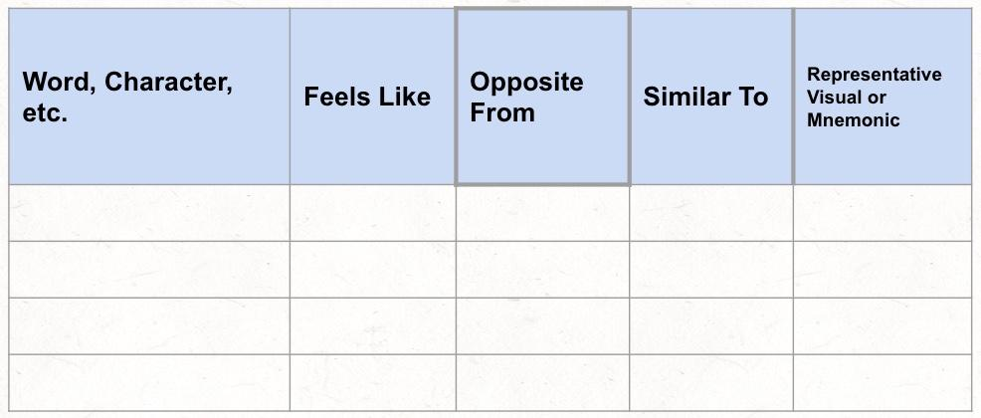
Student will sort and classify (events, attributes, objects, vocabulary) and then provide labels and short summaries of what categories were used and how items are alike and fit into the category. Allow for a second sort and re-classify if time permits or student is older. |  | Complete assignment  Text questions
Student will select one of three somewhat random pictures (provided by teacher) to compare to learning from the prior day and will explain how these are similar in two to three sentences. |  | Anticipatory Set  Warm Up
Student will keep a journal of analogies found over a [two-week] period of time and then share and discuss with teacher for [10 minutes] to formatively assess understanding of analogies or to assess growth in understanding of analogies. |  | Formative Assessment  Summative Assessment

Flexibility
ALP Goals: (1) Student will build flexible thinking by using an alternative perspective in place of traditional assignments or assessments (e.g., text questions, essay prompts) [once per month]. (2) Student will build flexible thinking by identifying, classifying, and forming patterns, combinations, and relationships based on classroom content and documented through alternative assignments [once per month.]

Progress will be measured through student self-assessment using rubric and teacher-student evaluation meetings [once per semester.]
Thinking Skill | Practicing through | Measurement by
Flexibility | Alternate perspectives  Classifying  Recognizing and forming patterns, combinations, and relationships | Student self assessment and debrief with teacher [once per quarter]
Strategies |  | Works well in place of
Student will use SCAMPER as a tool to rewrite endings, chapters, or essays.  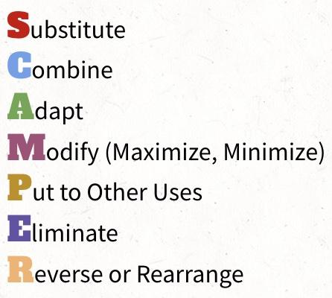  SCAMPER as a shareable slide deck |  | Complete assignment  Modified assignment
Student will represent [a fraction] in as many different ways as possible. |  | Anticipatory Set  Warm Up  Check for Understanding  Formative Assessment  Summative Assessment
Student will use inductive reasoning in [content area] to identify, classify, and form patterns or relationships. Please see this great blog post on what inductive thinking is as well as a good example of how to use it in the classroom.
Student will represent the same concept in at least [two] different artistic mediums.
Student will artistically represent the same object from different perspectives/angles. |  | Exit ticket  Warm Up  Essay or Writing Assignment
Student will rewrite or retell a fictional story in a different genre or from the perspective of a different character.
Student will research and then present both/multiple sides of an issue verbally or in writing. |  | Complete assignment

Elaboration
ALP Goal: Student will improve ability to elaborate in a specific content area by focusing on details and unanswered questions. Growth will be measured by collecting three to seven assignments in a portfolio over a [quarter, semester] that demonstrate an increase in number of elaborations. Elaboration will be assessed through student reflection and rationale for selection of portfolio pieces.
Thinking Skill | Practicing through | Measurement by
Elaboration | Details  Unanswered Questions | Student-led portfolio with reflection and rationale
Strategies |  | Works well in place of
As an introduction or extension to a lesson, student will describe a scene, character, or object using a certain number of details (minimum number of details required provided by teacher).  Visual Thinking Strategies  New York Times What’s Going On in This Picture? |  | Anticipatory Set  Warm Up
Student will: (1) spend [15 minutes] trying to generate solutions to unsolvable math problems (conjectures). (2) make a list of questions that remain unanswered after multiple attempts.
Multiple trials result in further elaboration!
Student will: (1) define the details of a [scientific concept, story, character, history lesson] on a graphic organizer; (2) pull out one detail and then define the micro-details of this detail.
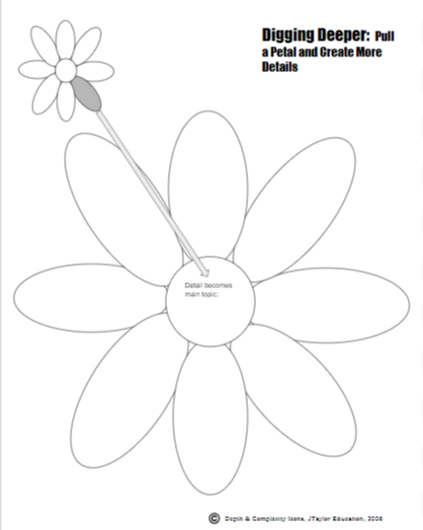
Student will select an element or scene from a book or movie, and add a new scene, chapter, discussion/dialogue or will introduce a new character.
Student will expand on the results of an experiment by considering: What is unanswered by the current experiment? What else could we learn?

Abstractness
ALP Goal: Student will demonstrate knowledge and/or mastery of unit concepts in at least [two content areas] through abstracting on assignment alternatives and/or alternative assessments [once per quarter.]

Thinking Skill | Practicing through | Measurement by
Abstracting | TWO content areas  Applying abstraction | Alternative assignments or assessments
Strategies |  | Works well in place of
Student will: (1) describe an object or summarize a text in a short paragraph; (2) rewrite with half the number of sentences; (3) rewrite again with half the number of words.
Student will: (1) highlight all information in a text that is important to the lesson; (2) Repeat again with half as much highlighting allowed.
Student will create a blackout poem from text by eliminating words that are not necessary but retaining message or theme.
Student will practice alternate notetaking strategy, SQ3R to actively use abstracting as part of daily learning.
[Survey, Question, Read, Recite (abstracting), Review]
Student will summarize the most important aspects of a (text, lesson, unit, experiment, concept) in a six-word story or a Tweet.
Student will create a one-frame comic that demonstrates the concept or theme (social studies, political science, novel). |  | Formative Assessment  Summative Assessment
Student will find/draw a picture that demonstrates the primary concept and explain it (in writing or verbally). |  | Formative Assessment  Summative Assessment
Student will develop for a younger student an explanation of a complex math problem or scientific concept. |  | Formative Assessment

