Student Affective Goal(s)
Student Name (Use a code here): | Date: | Grade: | Identified Strength Area(s):
Target:

Standard/outcomes:

Structure of Delivery:
Type of Programming & Measurement
Learning Experience: |  |  | Measurement:
Program or Model: |  |  | Measurement:
Intervention: |  |  | Measurement:
Behavior Modification: |  |  | Measurement:
SMART Goal: |  |  | 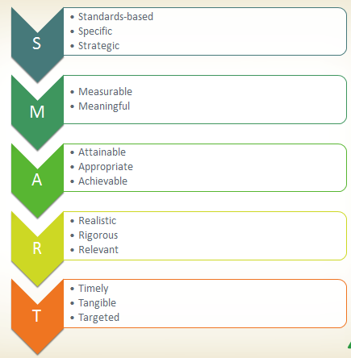
Academic SMART Goal Worksheet

