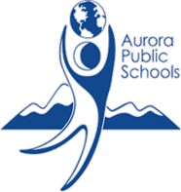

Gifted and Talented
Challenging the Edge of Potential

Date ___________________________

Dear Parent(s) or Guardian(s),

Attached please find two copies of your child’s updated Advanced Learning Plan (ALP). This has been saved currently as a draft until you have had time to review the goals and other information. We have included in this document your input from the parent and student surveys, if they were available at the time of our review. Please note that because ALPs are reviewed annually, academic goals are written based on the Colorado Academic Standards for the grade level above this school year in your child’s identified area of strength. Affective goals are chosen based on social and emotional areas to be developed.

If you feel that these goals meet your child’s academic and affective needs, please sign next to your name on one copy and return it to your son/daughter’s teacher. That will allow us to finalize this plan in our system. The second copy is for your records.

If you have any questions about the contents of this ALP, please contact your child’s teacher so your questions can be answered and any necessary adjustments can be made to the plan before it is finalized.

Thank you for helping us better serve your child’s needs.

Sincerely,

