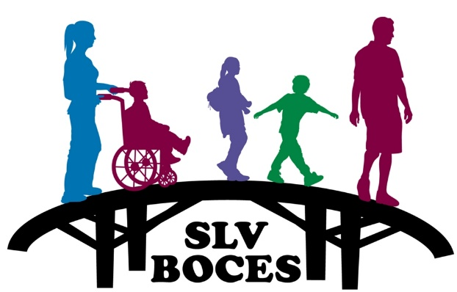

San Luis Valley BOCES
2261 Enterprise Drive
Alamosa, CO 81101
719-589-5851
www.slvboces.org

Letter Declining Medical Care

I, ______________ ___ ________, AM DECLINING MEDICAL TREATMENT DUE TO A WORK RELATED INJURY AT THIS TIME. I UNDERSTAND THAT I MAY REQUEST MEDICAL TREATMENT IF NEEDED AT A LATER TIME.

_____________________________ ______________
Employee Signature Date

