Viewing and Updating Caseloads

To view students that are linked to you as part of a team or IEP process, find and click on your Student Group called “Special Education” (see image on p. 6). This Special Education group is considered your caseload and your responsibility to maintain in Enrich. Once in this view you will see a list of students connected to you through various processes. Purple indicators next to a student’s name indicate that the child has a special program, such as special education. If you have access to a student’s file based on your school access, the student’s name will show as a link. If you do not have access (i.e. student moved to a new school) then the student’s name will be grey.

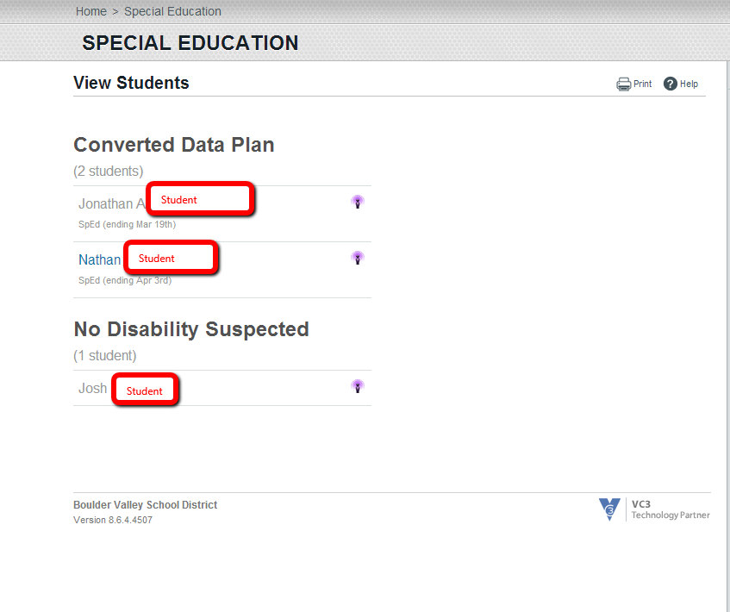

Cross check this list of students under your “Special Education” group with the list of students that you should have on your caseload. To remove a student from this list, notify your Records Specialist. To make this changes such as team manger or adding or deleting personnel to Enrich in this section, please notify Records Specialist so the appropriate special education staff member can changed. In Enrich, team lead is the name used for case manager.

IMPORTANT: If a student leaves the district please print and complete a “change of status form” from the SLV BOCES website either in the Enrich TAB/Enrich Guide section OR in the Departments TAB/Exceptional Student Department section/Forms in Special Education. With the submission of the “change of status form” Records can end the program for this student in Enrich using the appropriate reporting reasons. Students cannot be removed from your caseload until this form is submitted.

To add a student to your caseload, search Enrich for that student (see directions on Finding a Student) or contact your Records Specialist.

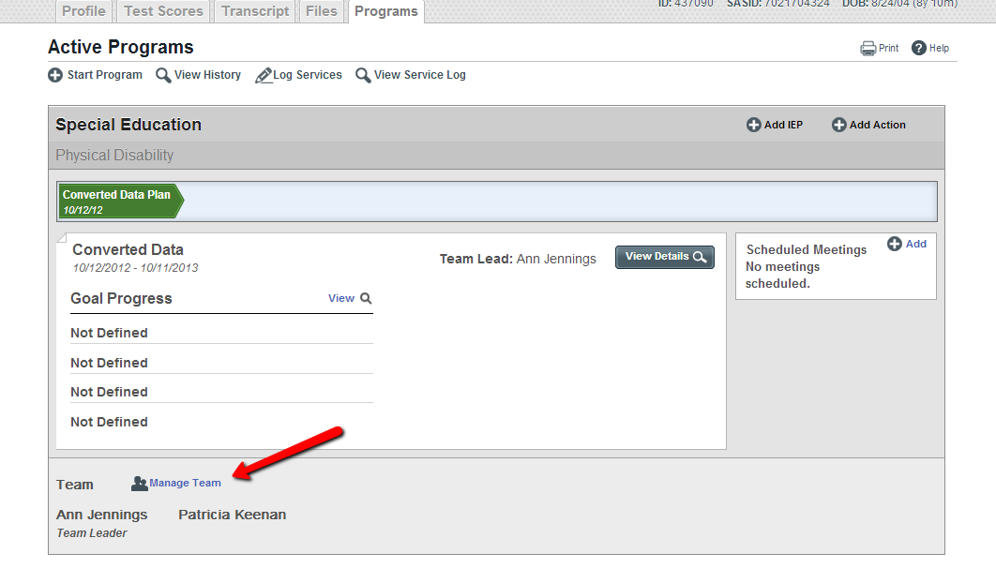
If you cannot find the student using the Search option, please notify your Records Specialist and request you be added as a team member.

