Uploading Required Documents
Make sure Enrich has uploaded signed copies of the following when appropriate:
  - Prior Notice & Consent for Evaluation
  - Referral to special education if going to evaluation
  - Prior Notice & Consent for Initial Provision of Services
  - IEP Page 2 (Procedural Safeguards and IEP Participants)
  - Permission to Invite Agencies Related to Transition
  - Request to Release Secure Confidential Information
  - IEP Team Member Excusal
  - Transfer Student Within the State
  - Transfer Student from Another State
  - IEP Amendment
  - Team member signatures for Eligibility
  - Summary of Performance
To upload you must have the document scanned and saved to your computer. In the Enrich Program, go to the Program Tab, Open the IEP. In the green section, scroll down to the Attachment Section. Find the word “Upload”. Click here. See image below:
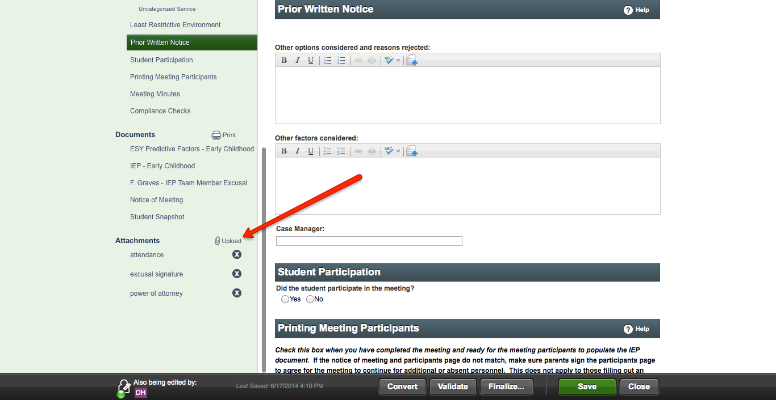
When you open the “upload” icon. A box appears that asks you to choose file. Click on the choose file box, you will be taken to your computer. Find the document you want to upload. Label it in the Label Box. Once these steps are completed, click on the “upload” box and the document will be uploaded into Enrich. The document title will appear and can be opened as a PDF. The document can also then be located in the Files Tab, the Attachment Section.

