**Translated Documents in Enrich**

In order to have an IEP translated, **wait to finalize**. The Spanish IEP in Enrich can be transcribed and saved before finalization of the English version. Follow your district process for IEP transcription. The profile of the student MUST indicate Spanish speaking. Talk to your Records Clerk if child is English speaking and family wants Spanish IEP, they can fix the profile so that the Spanish IEP can be accessed in Enrich.

To allow printing of documents in Spanish, select an alternate document language from the student’s Profile tab. Clicking the “Language Options” link allows the user to select a language in addition to English for printing of documents. **Note: At this time Spanish documents are uploaded for all forms. Other languages are not available as of yet.** 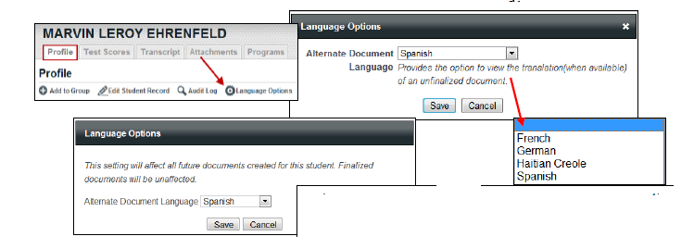

Next you will need to go to the Programs tab and create or find a document as usual.

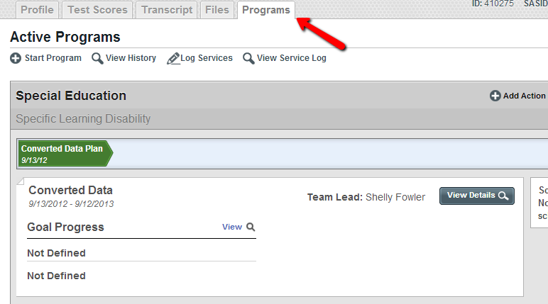

**TRANSLATED DOCUMENTS GO AWAY WHEN ORIGINAL ENGLISH DOCUMENTS ARE APPROVED. MAKE SURE TO UPLOAD THE TRANSLATED DOCUMENTS INTO THE STUDENT FILE**

When printing draft documents under the Programs tab, the option to View in another language displays at the top of the document screen. This appears when you click on the title of the document as seen below.

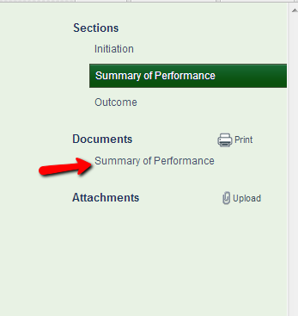





In this example, clicking View in Spanish, provides the option to download and open or save the document and then to select the program with which to open the translated document.

The document opens in MS Word to allow for additional editing of input fields, if desired. The document can then be saved and added to the student record using the Attachment feature.

Another option is to click the “Print” icon under the *Documents* section. In this option you will see *View in Spanish* noted next to each relevant form. The same process can be followed to click on *View in Spanish*, wait for the download and then edit or print from there.

