Transition Services

Remember that transition services differ from Special Education Services in the “Services” section of the IEP. All “Services” from the “Services” section of the IEP must be written into the “Transition Services”. The guidelines state that we describe the transition service as what the adult provides. The services must be specific. An example is: Resource Room Teacher provides direct instruction in reading comprehension and fluency. Another example is: Guidance Counselor provides direct instruction in study skills, how to take notes, how to take tests, how to memorize information. These services must also link to the course of study. See below first image for Independent Living.

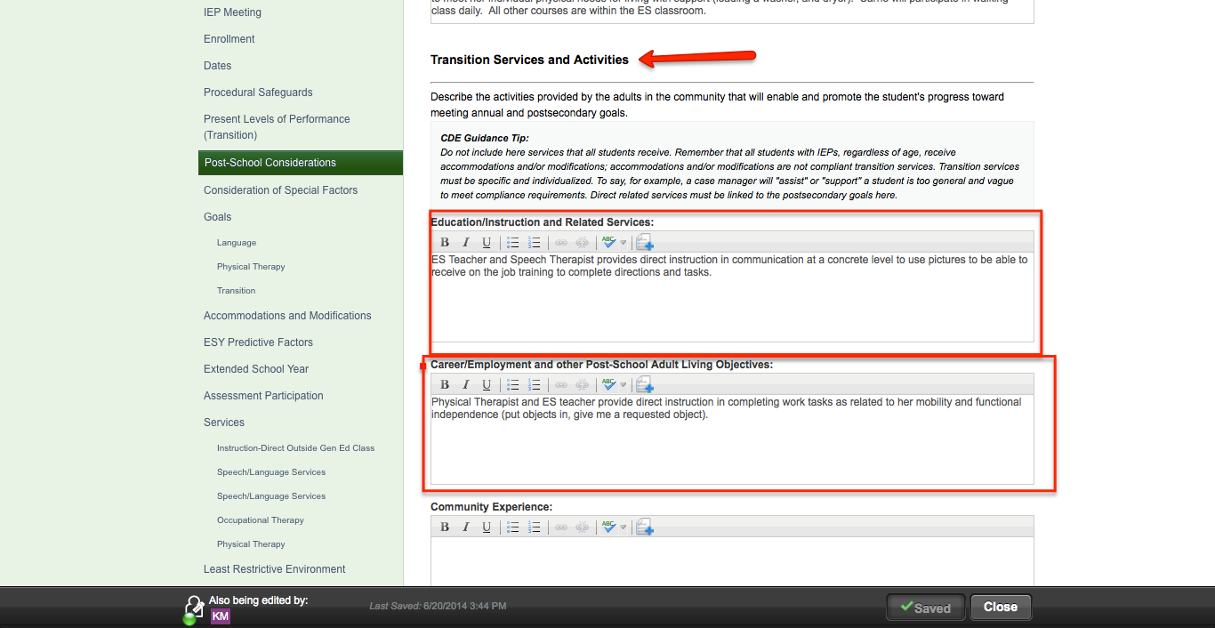

Independent Living Transition Services are required for student with significant support needs or high needs in this area.

