Services Log

SLV BOCES is requesting that all Related Service and Itinerant Staff log their services in Enrich. Special Education teachers assigned to one school in a district are not required to log their services.

If you created a student group (by school/district/age/etc.), go to student groups and select the group you wish to document on the service log:

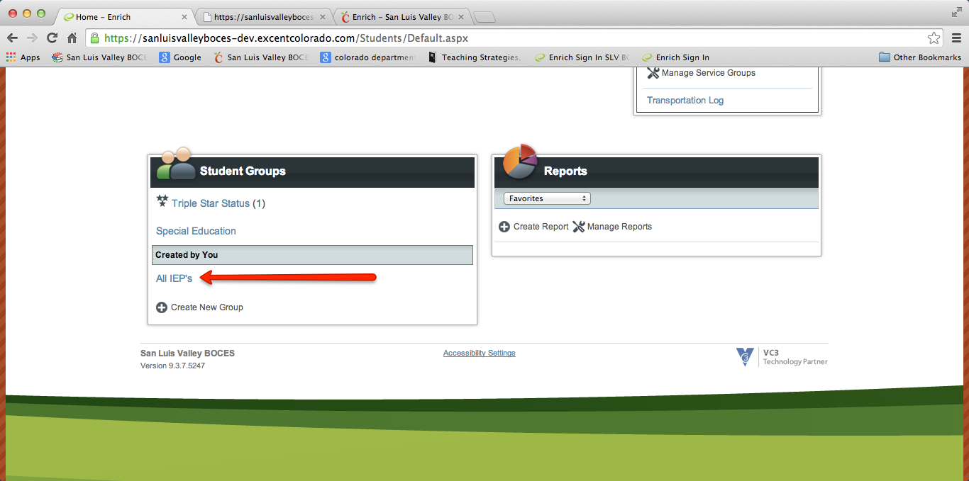

Then select the student you will be updating the service log for:

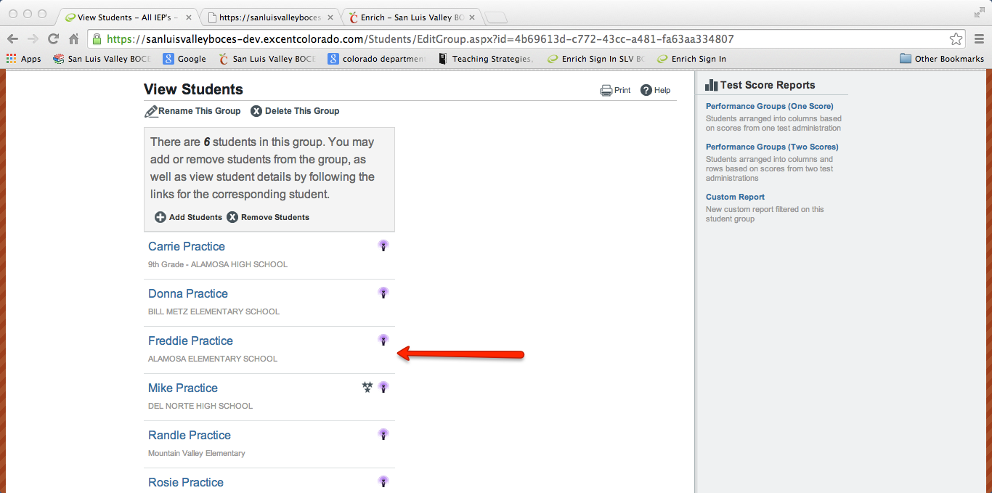

Go to the Programs Tab of the student. Find view services log. Click on that link. (See image below)

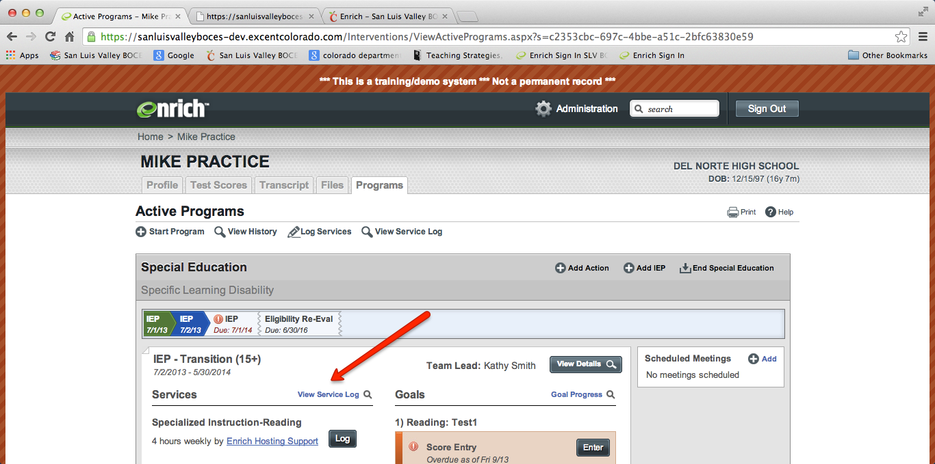

Click on the Log Services (there is an image of a pencil next to the words)

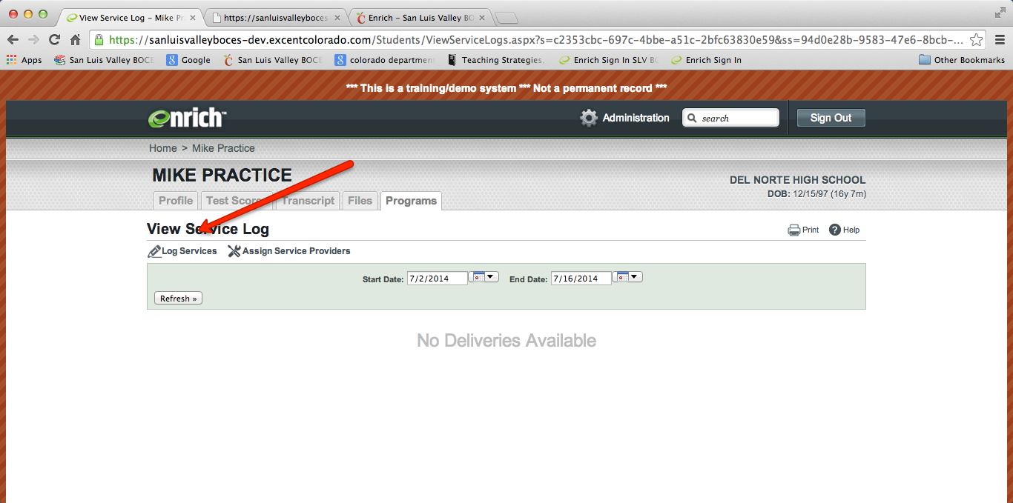

Select the service from the drop down menu. Select the provider from the drop down menu. (For SLP-A’s and SLP paraprofessionals, select the supervising SLP and use your initials in the text box documentation to verify you were the provider—this is so we can run reports for who receive SLP services.).
(See image on next page).
