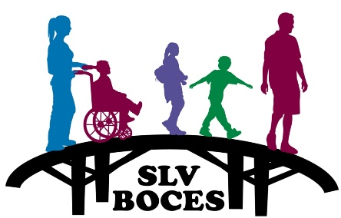
San Luis Valley BOCES ESSER III Funding Plan
The San Luis Valley BOCES (BOCES) received notification of its ESSER III state set aside allocation of supplemental funds in the spring of 2022. The total allocation is $162,864.57 ($121,351.73 for any allowable activity & $41,512.84 to provide supports/services to SpEd students). Of this funding, it’s being required that a minimum of 20% of these allocated funds be used for interventions to address the academic impact of lost instructional time. The funds must be spent by 09/30/24.
The BOCES does not enroll students, but supports students that are identified with special needs and are enrolled in one of the 14-member school districts. The BOCES plan for the use of ESSER III funds is outlined below. In order to determine the best use of these funds, staff made a diligent effort to participate in ESEA office hours, attend trainings and to review guidance in order to properly budget for ESSER III funds. Please note that the budgeted amounts are approximate and may change; therefore, prompting a Post Award Revision (PAR).
Any Allowable Activity
Cleaning Services (July 2022 – June 2023) | $8,320
Personal Protective Equipment | $450
Zoom Room Renewal in March 2023 | $1,400
IXL Service Site License Upgrade | $2,800
Extended School Year - June/July 2023 (20% Set-Aside)  Salary/Benefits  Supplies | $20,000  $5,000
Compensatory Services - 22/23 School Year  Salary/Benefits | $10,000
Speech Camp Sal/Ben June 2022 (Split with ESSER II) | $3,333.03
iPads | $3,500
Assistive Technology Devices | $29,281.53
New Sensory Classroom | $7,500
Reading Curriculums | $10,000
Professional Development | $8,236.17
Indirect Cost | $11,531
Provides Supports/Services to SpEd Students
School Psych Assessments | $5,000
Speech Assessments | $5,000
Sensory Materials | $15,568.84
Touch Math Curriculum (20% Set-Aside) | $12,000
Indirect Cost | $3,944
Grand Total | $162,864.57

