SOP and PWN for Graduation/Maximum Age Exit

Go to the Programs Tab, then to +Add Action.

ONLY open the Prior Written Notice for Graduation/Maximum Age, as once this form is complete the SOP will be automatically generated.

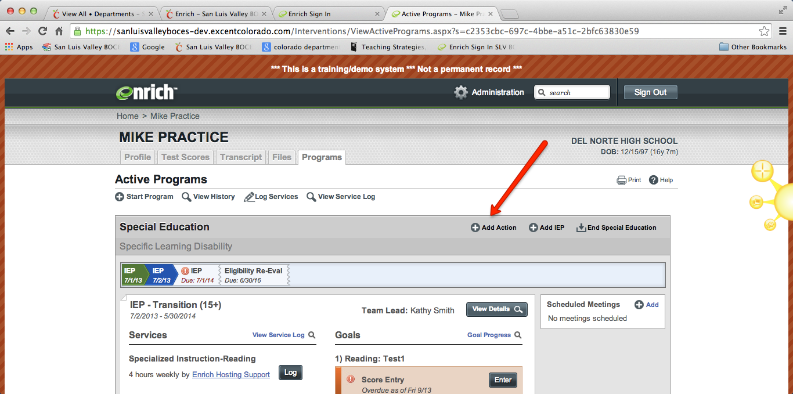

Open the PWN for Graduation/Maximum Age and select the reason. There are 2 reasons: Graduate with a Diploma or Teaching Maximum Age during the semester.

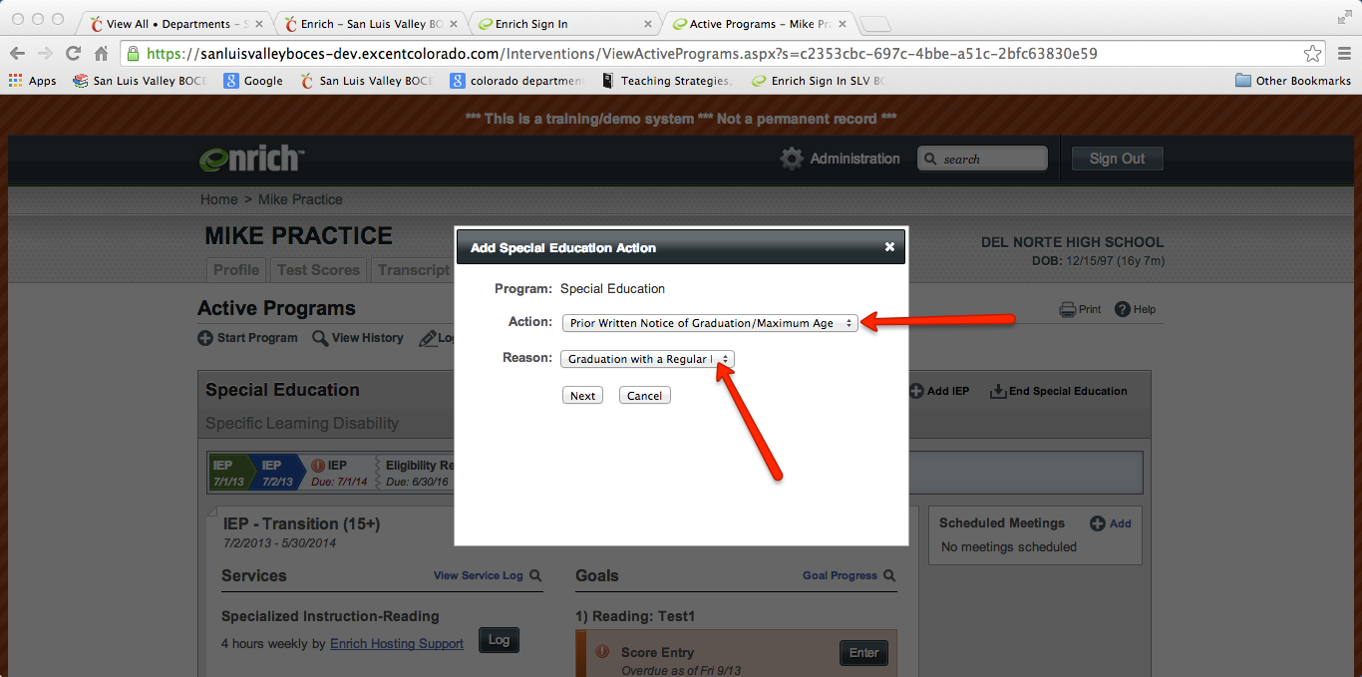

The PWN form will be generated. Complete and finalize the PWN for Graduation/Maximum age form. Notify your Records Specialist so it can be administratively approved.

The SOP will then automatically generate.

Complete the SOP, obtain a signature and upload the SOP signature page.

The SOP beginning looks like the image below:
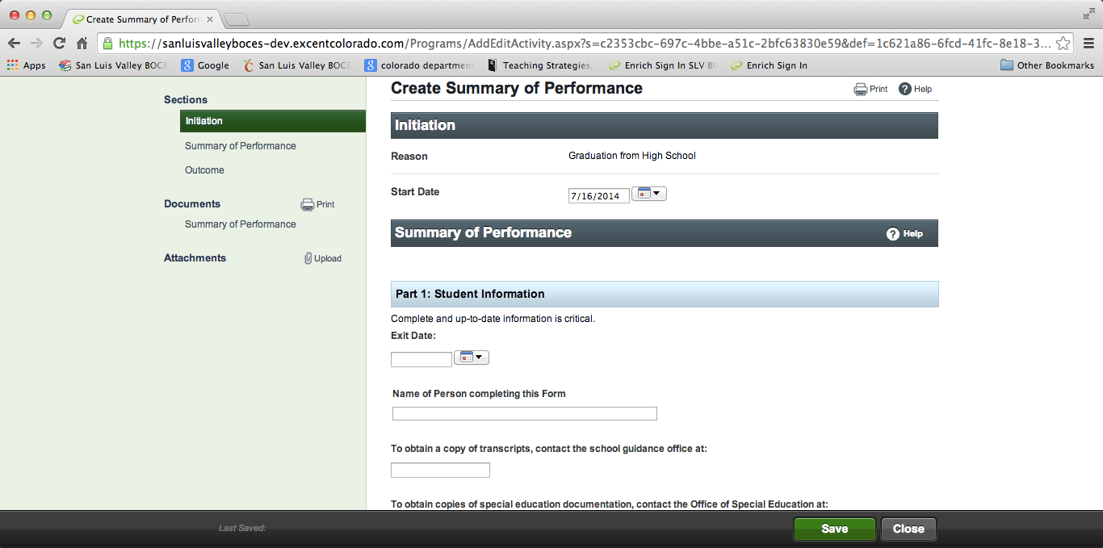

The printed version looks like this:
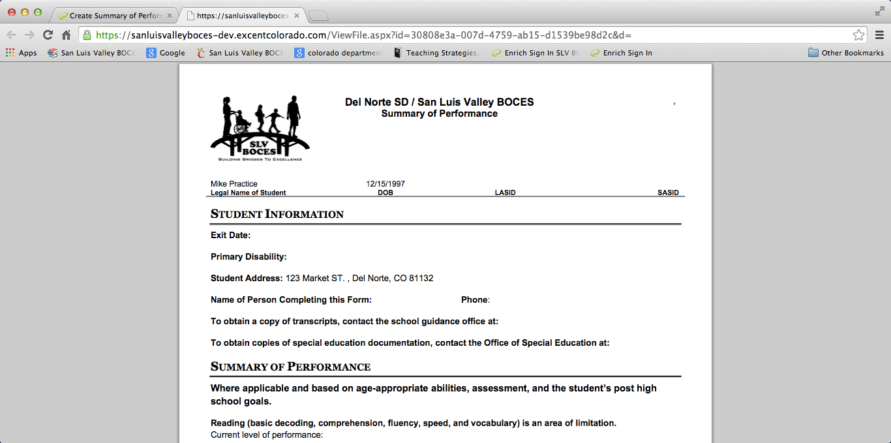

The signature page looks like this:
