Progress Reports
To access progress reports in Enrich you will need to access the Programs tab for a specific student. On this screen under the IEP you will see Goal Progress and a link to “view.” Click on “view.” Remember to update report cards following your district report card period and at annual review. Reporting periods are set by the IEP process and dates for reporting are set administratively using the latest dates of all 14 districts school calendar.

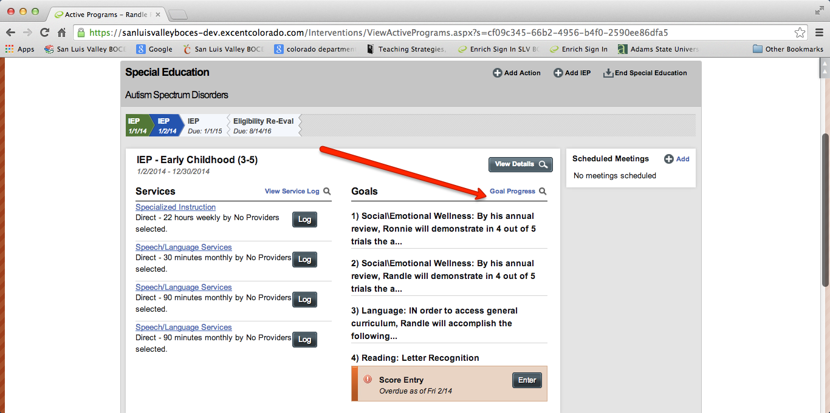

Once in the “view” screen you’ll have the ability to edit the progress report. Click on “Edit Progress Report”. Each goal is available for updates by scrolling.

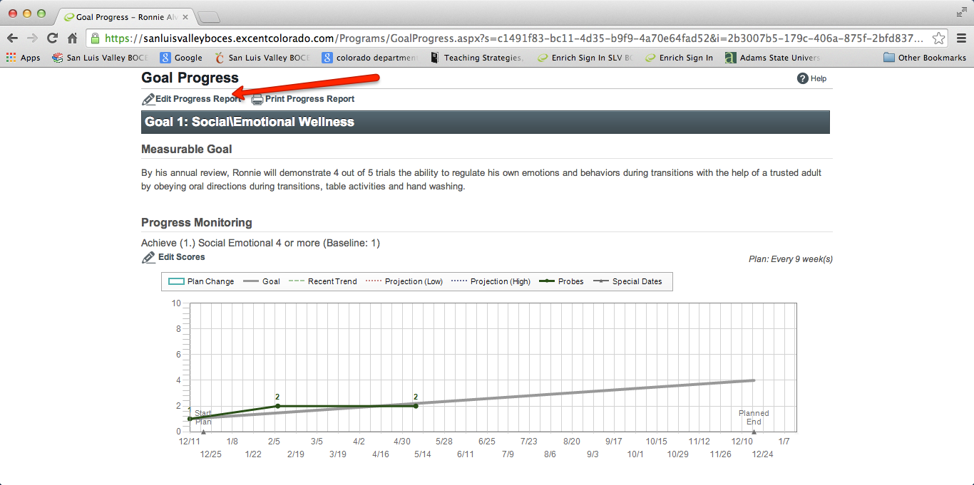
To print the progress report click the Print Progress Report while in this section. See image below.
