Progress Monitoring

To progress monitor by individual student, click on the second blue number in progress monitor section of your home page. To see all of your students at once see below.

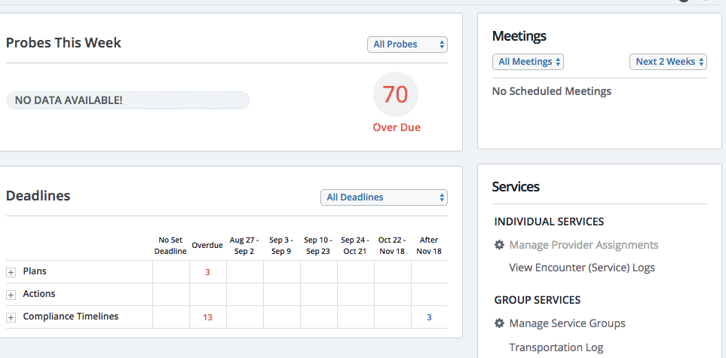

To progress monitor, viewing all of your students, go to the Student Groups at the bottom left hand corner of your home page..
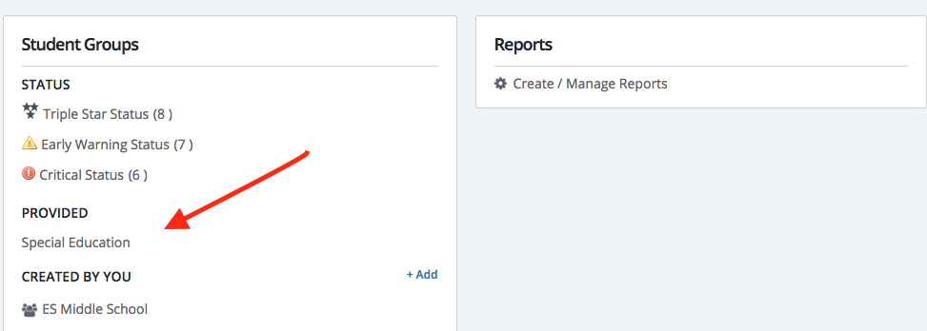

Select the student.

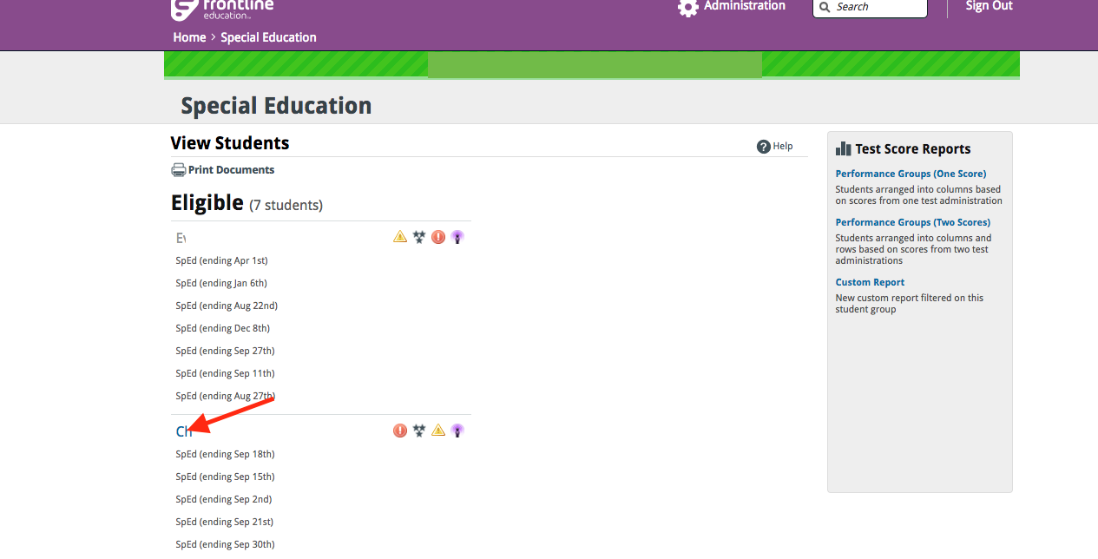

You can click on the purple probe or the child. On the student profile page, click on “goal progress”.

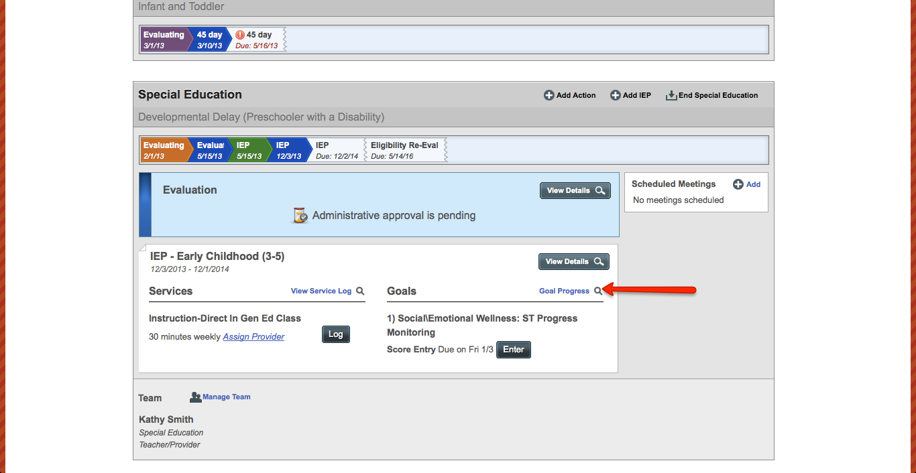

Next, click on “Edit Scores”. Add information for the reporting period for each goal that applies to your discipline.

