Overdue Documents
When an IEP or related document is overdue it will be noted as such on the teacher dashboard. See below for an example of a teacher who sees one overdue timeline on their teacher dashboard. If an IEP or action were overdue the teacher would see a value under Overdue Plans or Overdue Actions or Compliance Timelines. You can click on the number (in this case the 1) to view exactly what is overdue.
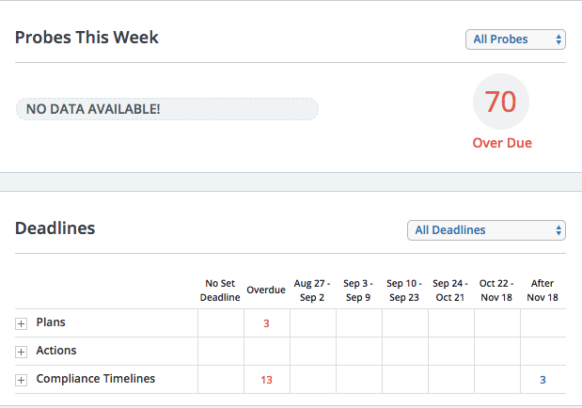
Within a student’s Program tab the teacher can see what is overdue as well. In the image below you can see that the circles with exclamation points next to the IEP and Initial Evaluation items in the horizontal bar indicate that these two items are overdue and beyond the 60 day timeline for an initial evaluation.

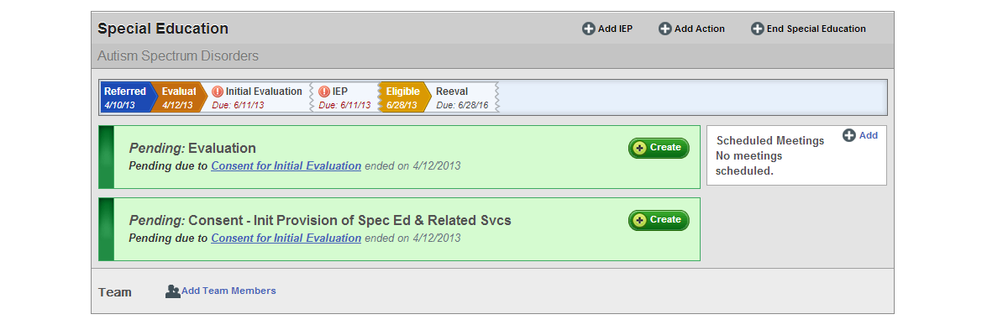

If the school psychologist were to go into these documents and finalize them he or she would be asked for a delay reason. This is part of the compliance checks element of the IEP or evaluation that can be seen in the image below.

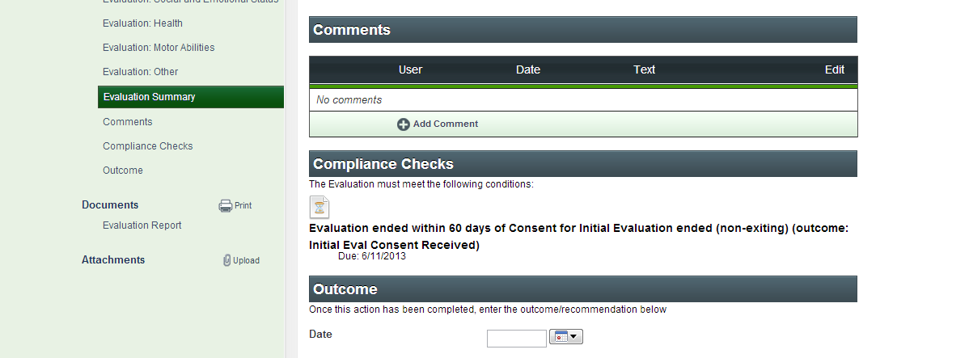

Once the school psychologist selects “finalize” on this document they will be prompted to select from the state approved codes for an IEP or evaluation delay.
It is the teacher’s responsibility to select the code that is relevant to the delay reason and to ensure that delays only occur in these instances.
