Notice of Meeting

Step 1: Click on Add next to Scheduled Meetings for the child for whom you are scheduling a meeting.

Step 2: Click Next
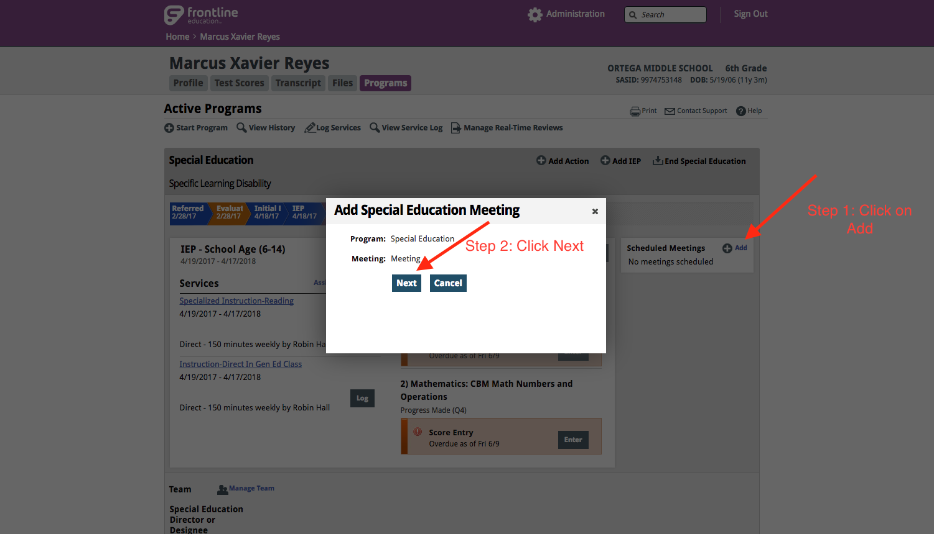

Step 3: Add Members to be invited to meeting

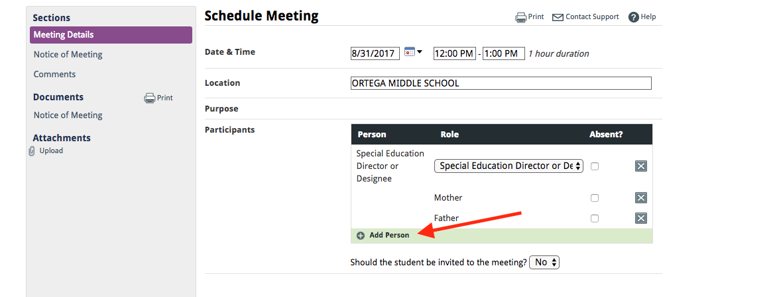

Step 4: Select the type of meeting (Note: Transition IEP’s will have 2 items selected Transition and then either IEP Review or Reevaluation or Initial IEP)

