Login & Dashboard
Use any browser to go to the following website (Google Chrome is recommended):
https://sanluisvalleyboces.excentcolorado.com/SignIn.aspx

- Type in your district or SLV BOCES network login and password assigned for Enrich

Click on “I Agree” to log in and indicate you agree to maintain confidentiality of records.

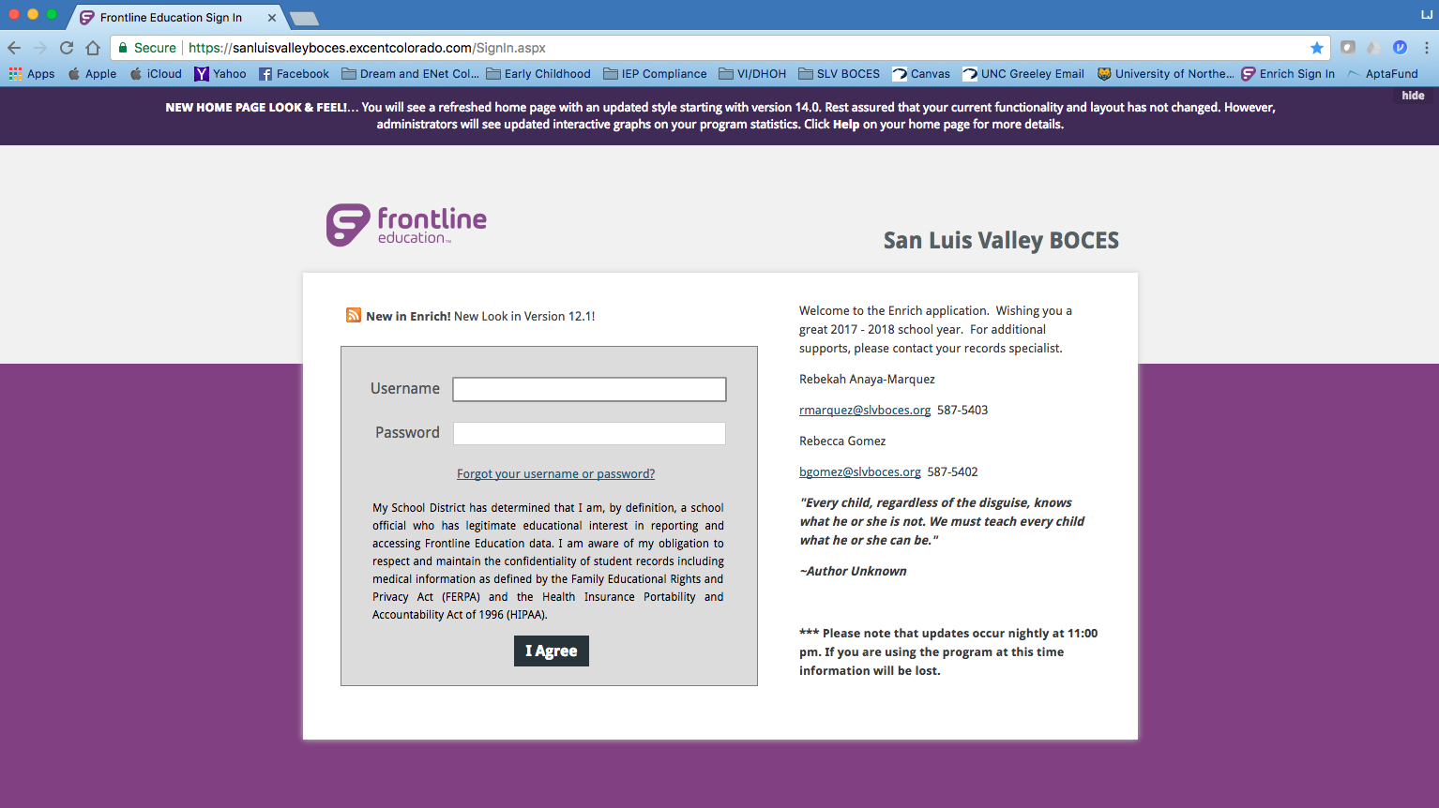

Dashboard Messages
Your Dashboard will inform you what is due and what meetings are coming up. Use your dashboard to inform you!
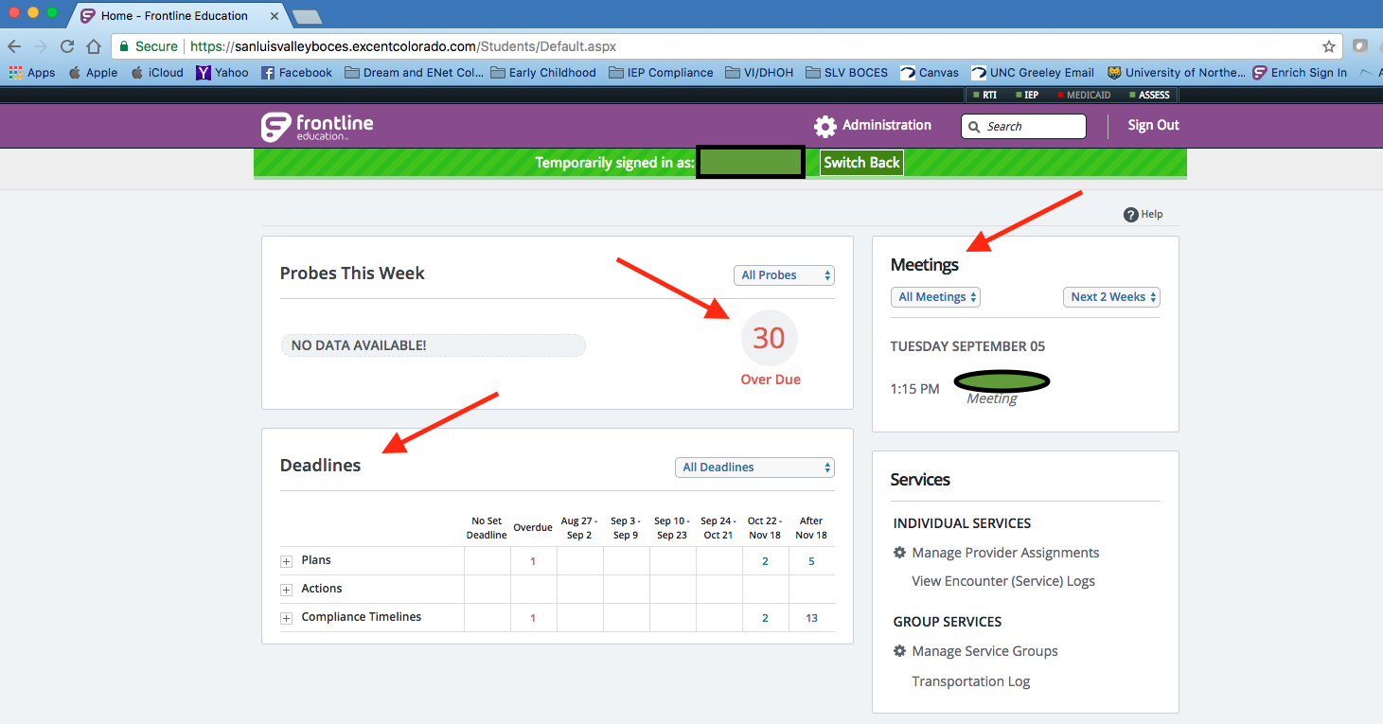

Scroll down in your dashboard and you can create groups of students (by need, by region, etc.) to help you manage lesson planning, IEP goals, etc. (See image below).

