To read your available leave time more easily, please follow the directions below:

- Login to aptafund.com using your BOCES email and the password you created.

- Go to “My Aptafund”

- Click on “My Leave Balances”

- Click on the blue funnel in the top right hand corner (see below)
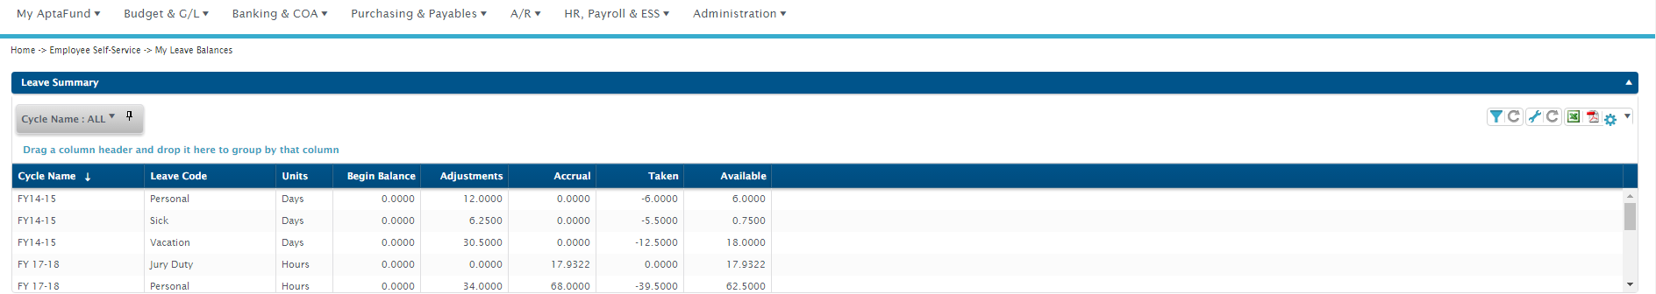
- After you click on the blue funnel, click on “Cycle Name” and you’ll see “select.” Click the down arrow and select the current year. Then click apply filter at the bottom.

- You will now only see your leave balances for the current year. You will want to look at the available balances in the far right column.

