IEP Amendment

To amend an IEP without an IEP meeting, go to +Add Action. Select IEP amendment, then next. (This requires parent permission, as documented by parent signature on the IEP amendment!). The IEP amendment form will be generated. An IEP amendment can be used to make minor changes to the IEP, change annual goals, reduce or increase services if the amount of service time does not change the LRE. If you are not sure if the change in service will change the LRE time, contact your Records Specialist. Complete the form and obtain parent signature.

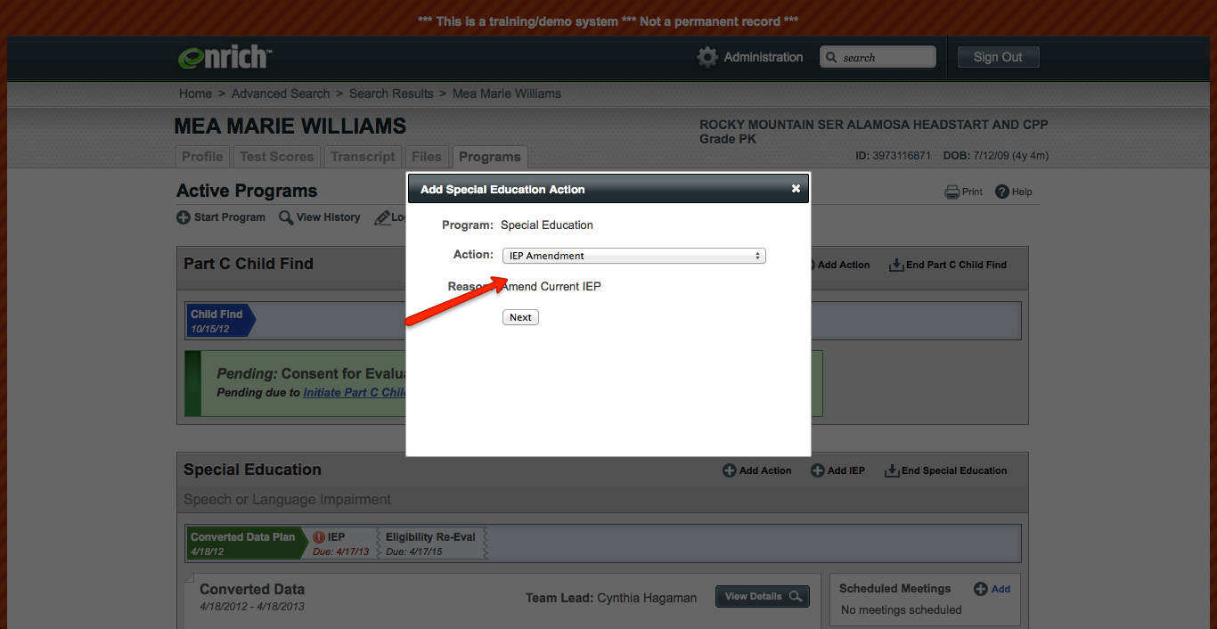

Once the IEP amendment has been signed by the parent, upload the form to Enrich and complete all of the additional required information. There are questions you must fill in and answer to finalize the IEP amendment.

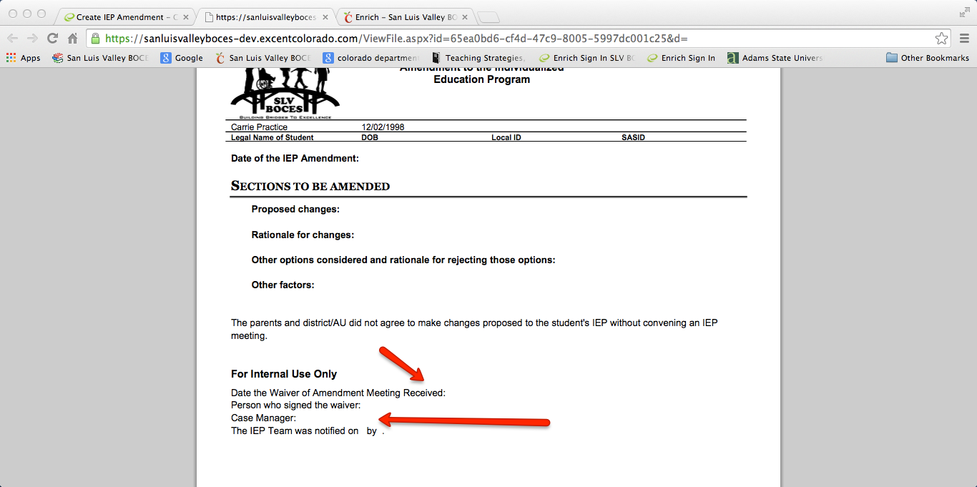

The IEP amendment form looks like this as a form in Enrich to be completed:
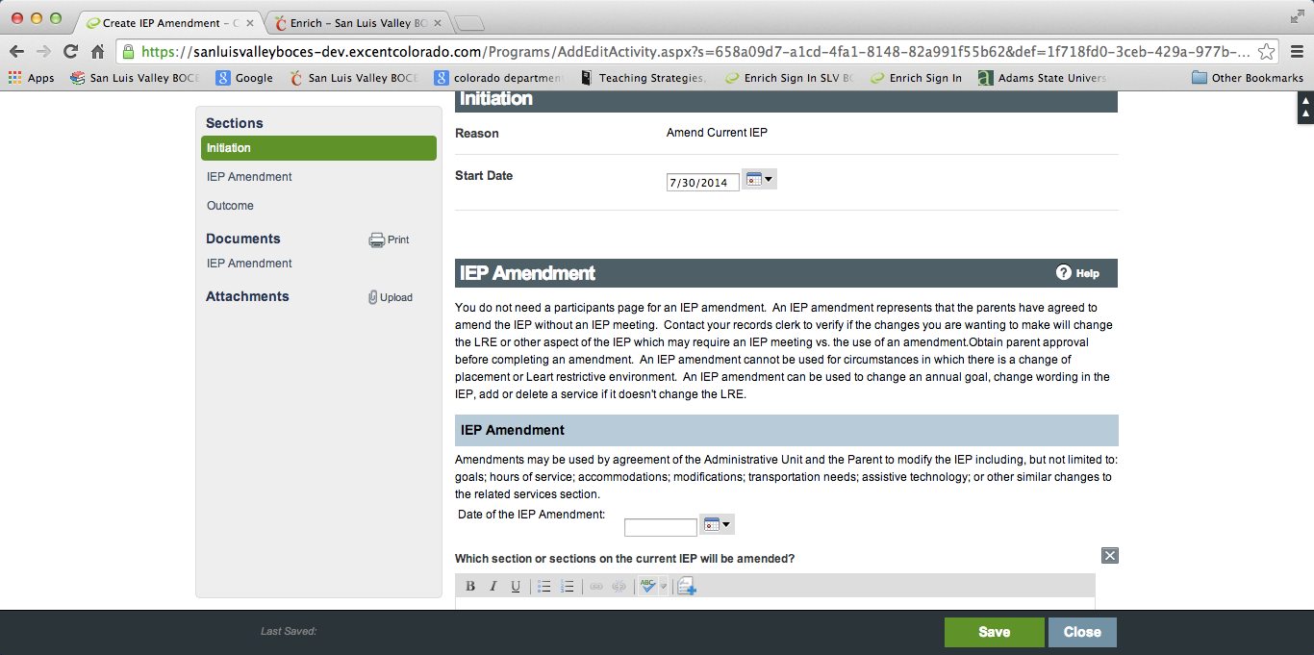

If you change services, on the actual IEP in Enrich utilize the amend button on the original IEP, change the end date to the original service so the service ends on the date of the amendment. Add the new service with the new beginning date and maintain the end to be due at the next due date (triennial or annual). Start and end dates do self populate, but can be overridden as described above.

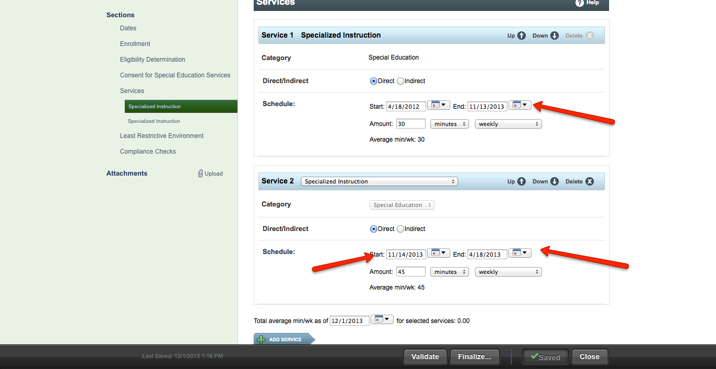

If you change or delete a goal, on the actual IEP in Enrich, change the end date to the original annual goal so the goal ends on the date of the amendment. Add the new goal with the new beginning date and new end date to be due at the next due date (triennial or annual).

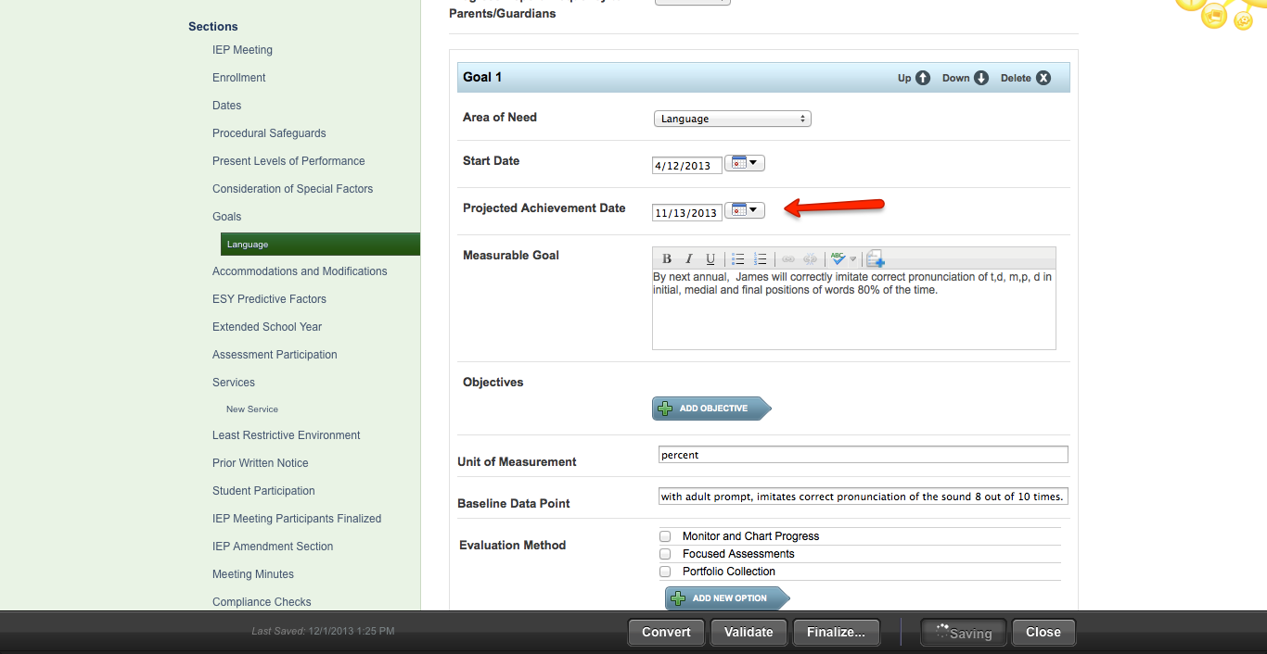

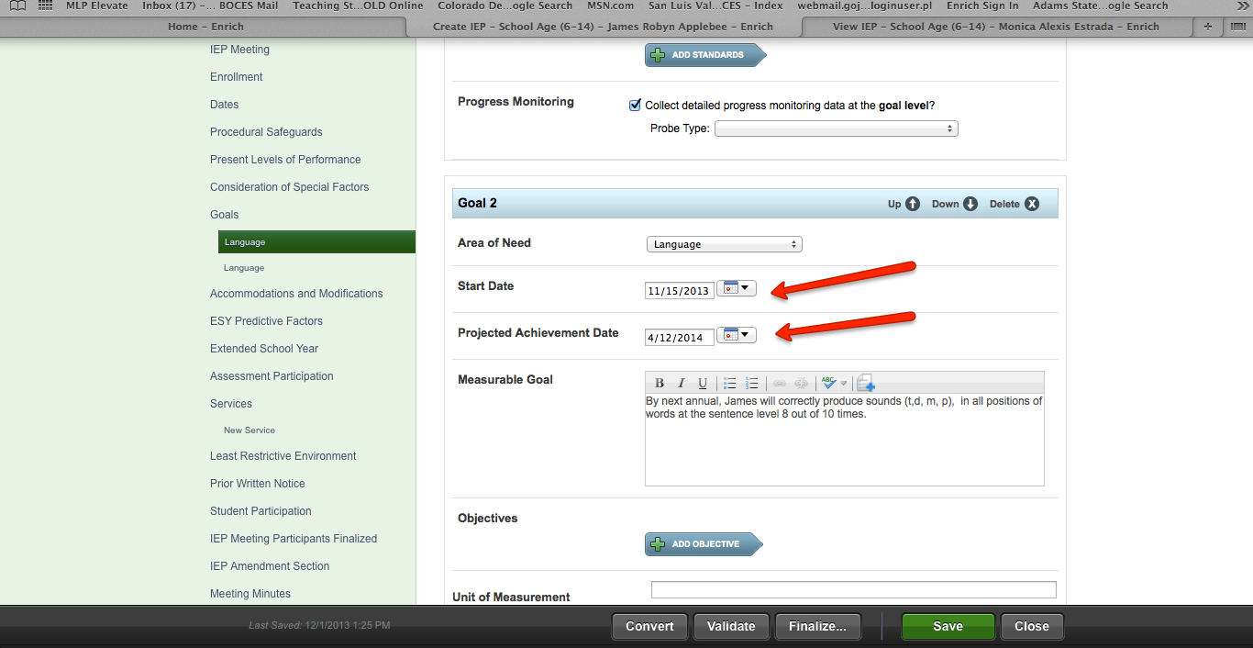

If you add special considerations, complete those considerations on the IEP in Enrich and date as of the IEP amendment approval date.

If you add information to the IEP, embed that information on the IEP. It is best practice to date the revisions on the IEP as you add them to the IEP. Prior Written Notice is embedded in the actual IEP amendment form and you DO NOT need to add information to PWN in the actual IEP.

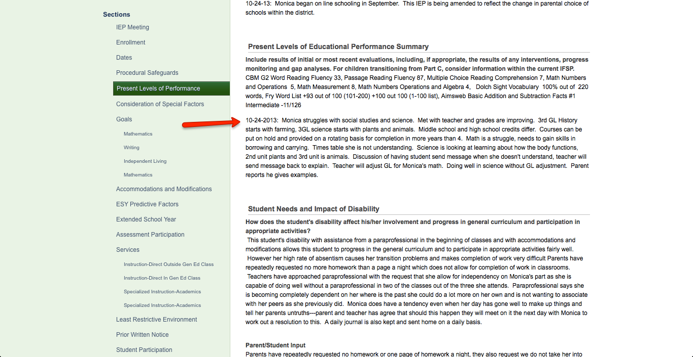

Lastly, there is a section in the IEP asking if the IEP is being amended. See image below and document Yes if the IEP is amended and parents agreed to the IEP amendment.
