1. Document gaps for Post Secondary Readiness/Preparedness in academic skills in Present Levels

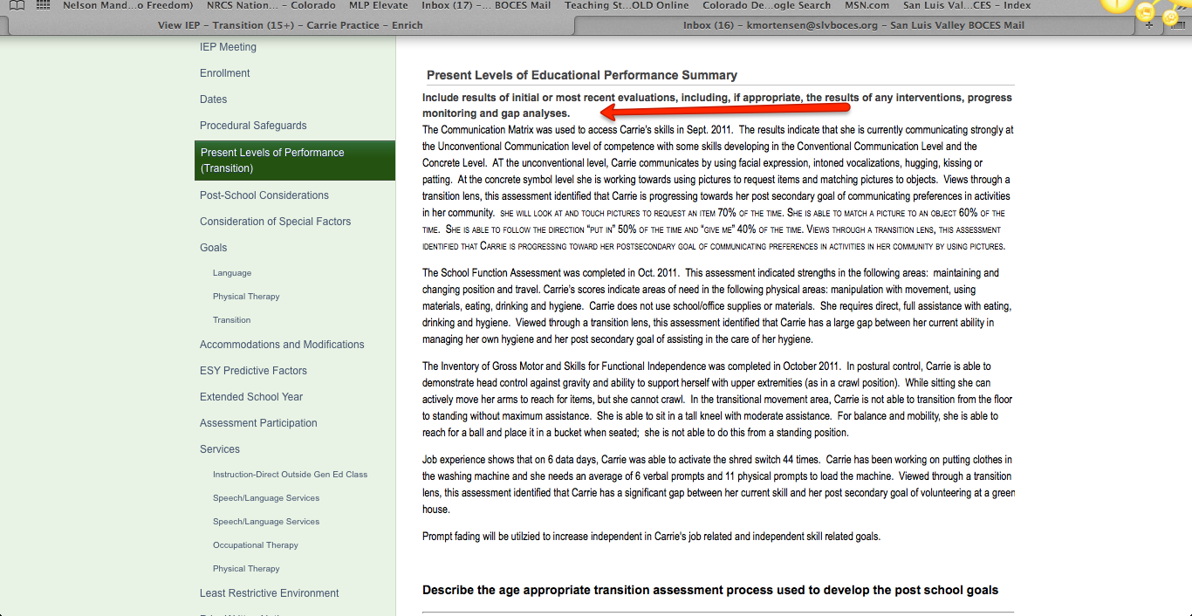

2. Document strengths and gaps in functional, independent living, social, work, and other skills needed for post secondary success in the Transition Assessment Summary.

