Finding the IEP AND The function of the Tabs

Enrich has program near the top of each student’s page. See image below.
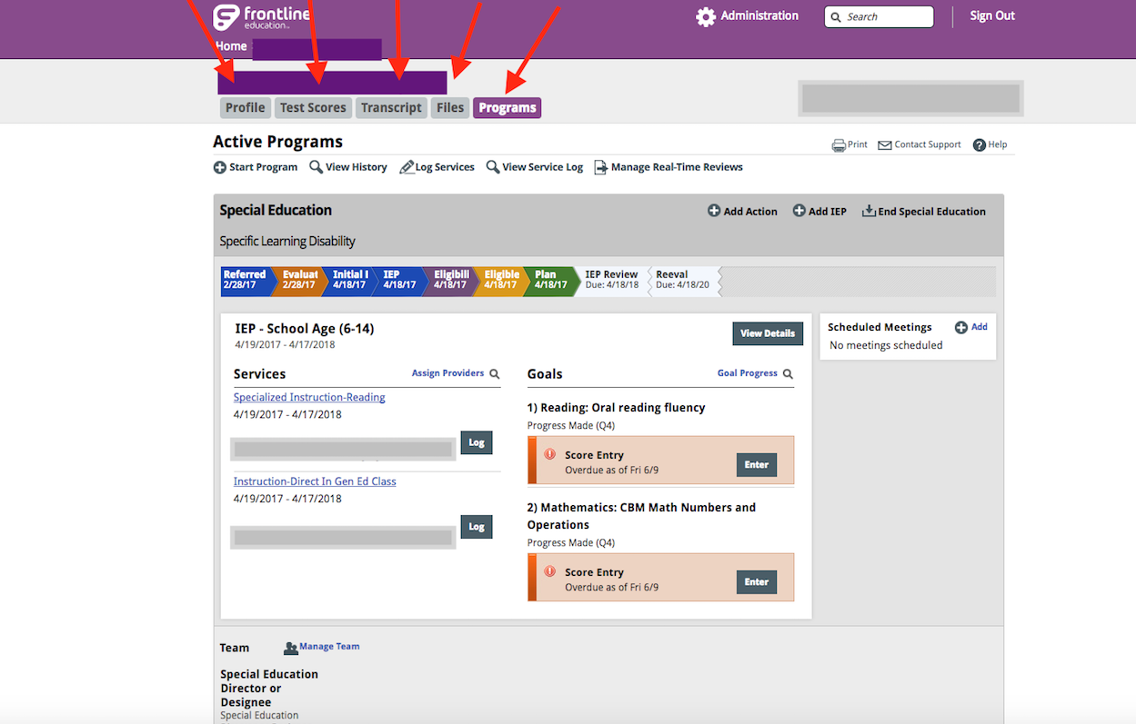

The profile tab contains the demographic information.
The test score tab will include district test score information ONLY IF your SIS system (Student Information System) is connected to Enrich. Only one district has this function so far.
The transcript tab will include transcript information ONLY IF your SIS system (Student Information System) is connected to Enrich. Only one district has this function so far.
The files tab will include all IEP’s and uploaded signature pages.
The program tab is where you access the student’s current information, access to “add” forms if needed, access to logging in services, progress monitoring, etc.

