Finding a Student

Once logged into Enrich, students can be found by searching the search menu seen in the image below. You can search by first name or last name.

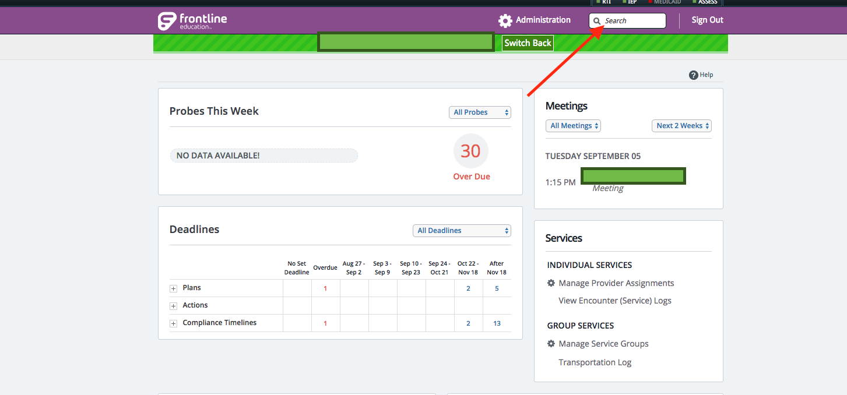

Advanced search options are available by selecting “more search options.”

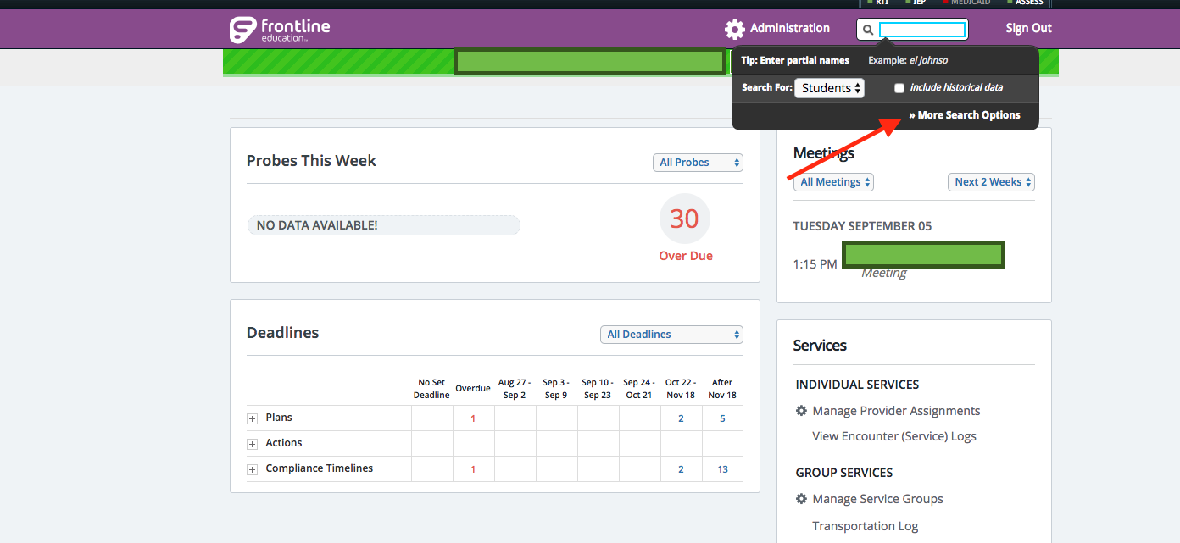

The “More Search Options” opens the view shown below. More Search Options can be used to narrow your search if you have several schools. Best practice is to search by student first or last name and either district or school. This advanced search option helps you find “closed” students as well.
