Finalizing, Saving, Validating and Converting

At the bottom of most draft documents in Enrich you will have four to five options: Convert, Validate, Finalize, Save and Close. We recommend validating often while composing the IEP so that you are aware of potential errors or places that have been “missed”.
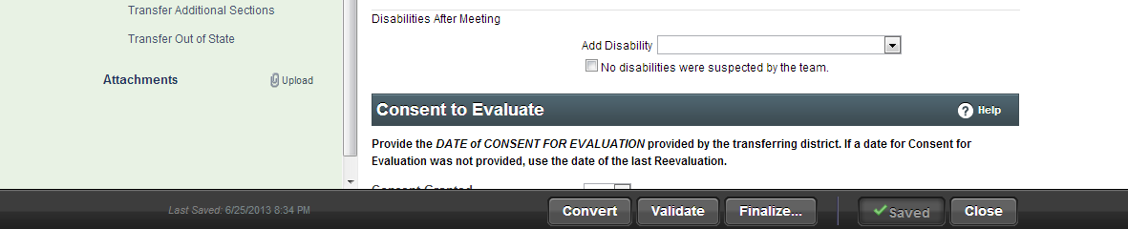

Convert: This button is used as an option when you are in an IEP document. Its purpose is limited to the rare instance when you create one type of IEP and then decide later that you should be using another type. For example, you create a school age IEP for a student who is 14. In the process the team decides to add some transition information and so a transition IEP is necessary. In this case select “Convert” and you can take the information you have been working on in the draft IEP and convert it into the new IEP type. You cannot convert an IEP once it has been finalized. It will have to be rewritten.
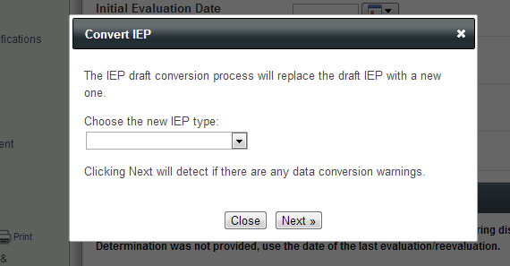

Validate: This option is a way to check your IEP for compliance at any time. Save the document and then select “Validate.” On the left side of the screen any areas that are considered non-compliant will be indicated with a pink highlight allowing you to focus on those prior to finalizing a document or sending a draft home to parents. You can see an example of this in the image below. In this case the teacher can click on the areas that are highlighted or scroll over them to see what the error is so that it may be corrected.
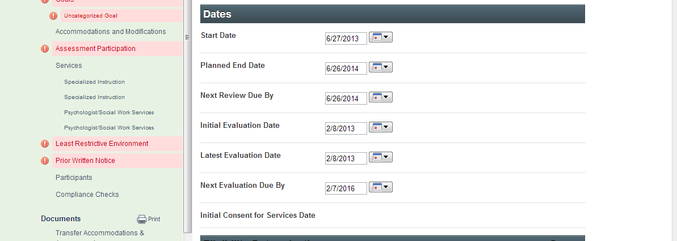

Finalize: An IEP will remain in draft form until finalized and most IEP documents will have “draft” printed on them until finalization occurs. A document should be used in draft form for the relevant IEP meeting. After the meeting is held and the document is completed with team input the document should be finalized. The case manager should finalize all IEPs and their supporting documents. To complete select “Finalize” at the bottom of the document. Enrich will check for compliance in the document and make you complete any required corrections. After corrections are made Enrich will allow you to check again to finalize the document making it a final version. At this time you can print final copies for parent. The case manager ensures parents get copies of these documents without draft written on them. Once finalized a document cannot be edited. Case manager is responsible for notifying Records Specialist to administratively approve the IEP upon completion.

Save: Possibly one of the most important tasks you can do. Save often as you work in Enrich as to not lose your work.

Close: This button will allow you to exit from the document back to the student’s Program tab. When completing your work in a draft document please save first and then close the document prior to exiting Enrich.

