Early Childhood Guidelines:

There are no state assessments (YET) for ECSE students. Mark no to all state and district assessments.

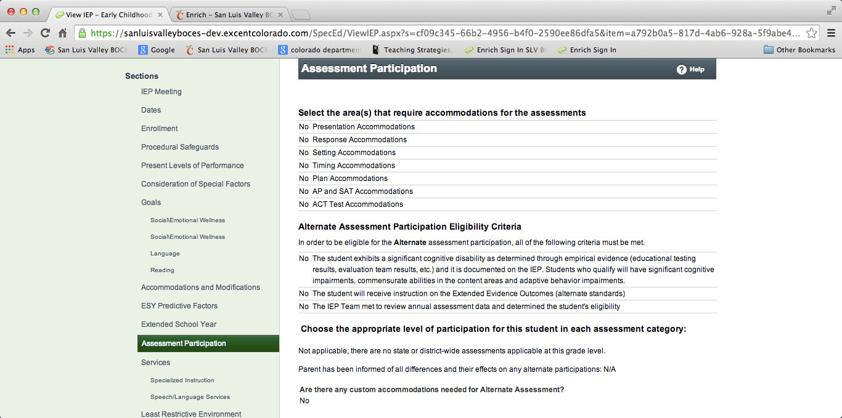

LRE Documentation:

SLV BOCES utilizes PPR funding for preschool. To make sure we meet legal fiscal obligations the following wording must be used in every IEP. The wording is slightly different for participation in a district preschool than a Head Start.
Attends Head Start 20 hours with 90 program hours per semester funded by the school district.
Or for District Preschool: Attends Preschool 12 hours a week funded by the school district.
Remember to document all early childhood settings the child attends. See image below. This student attends Head Start in the morning and a Child Care Center in the afternoon.
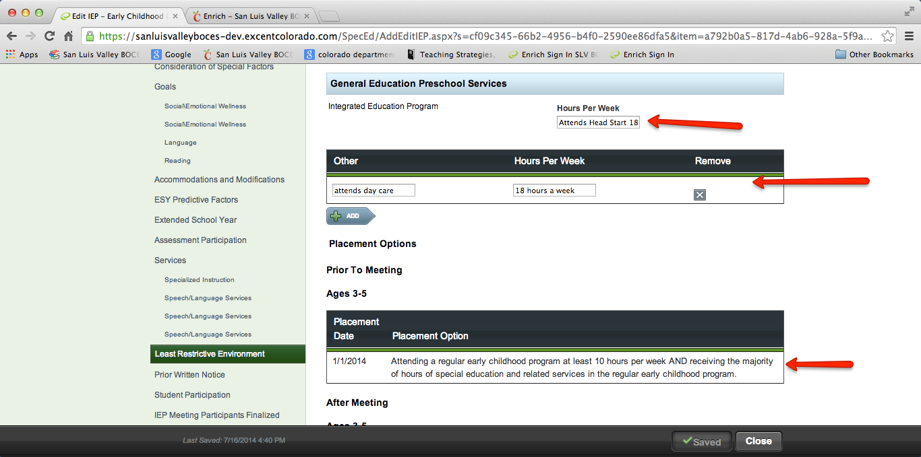

Special Request Meeting for Transition to Kindergarten:

If the Transition to Kindergarten meeting is NOT an annual or triennial (eligibility meeting), it will be a special request. Follow the special request guidelines and in addition remember to complete the following:

1. Send a new notice of meeting NOT attached to the IEP. Utilize the Add meeting button as shown below.
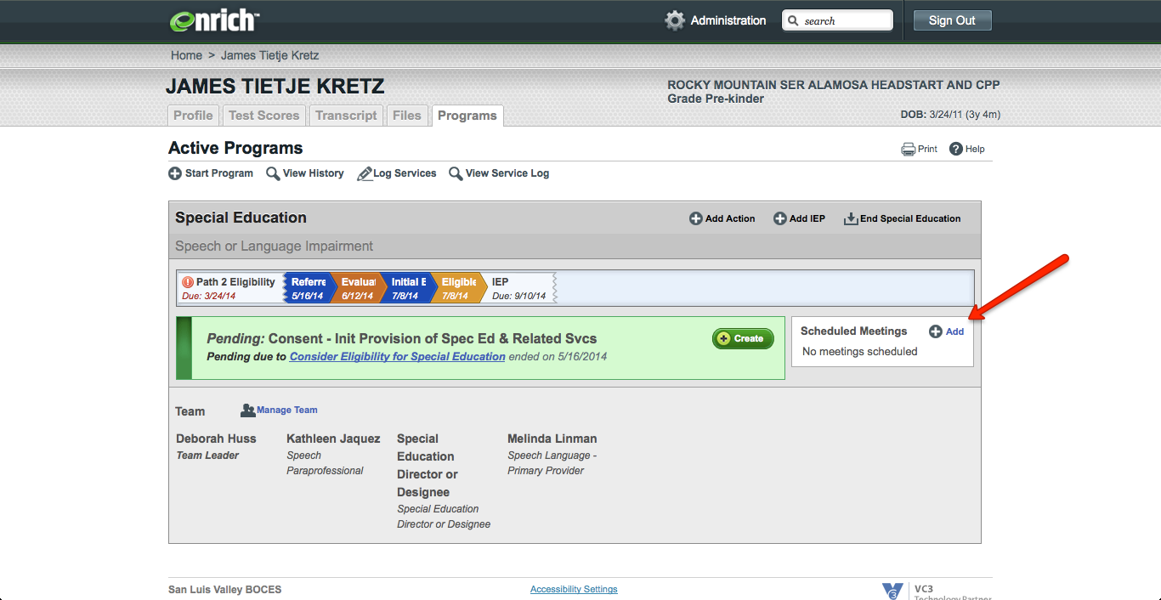

2. In the strengths, needs and impact of disability section: Add a new paragraph with the date of the special request meeting and add to the IEP discussion that occurred on these topics in each section.

3. Describe the special education services that will begin in the fall in the service delivery text box.

4. Add services that begin in the fall with end date when the next IEP meeting is due. End ECSE services with the last date of preschool attendance. SLP, OT, PT services can continue, other than changing SLP services to all being outside of class if that is applicable.

5. Add annual goals that will begin in the fall with end date when the next IEP meeting is due. End ECSE goals as the last date of preschool attendance. SLP, OT, PT can continue their goals or change them, depending on the decision at the special request transition to kindergarten meeting.

6. School district should follow their policy for meeting Literacy Plan Requirements for Kindergarten students. (Some districts embed the Literacy Plan in the IEP while others write a separate plan). This should be an agenda item to be discussed at the Special Request meeting.

7. Update the Prior Written Notice and Other Factors considered by adding the date of the meeting at the end of the last discussion and update the decisions considered, the decisions made and why decisions were rejected or accepted in this section.

Speech only students going to Kindergarten

At the annual review (or Initial if applicable), document SLP services in and out of classroom for the time the student will be in attendance at Preschool.
SEE IMAGES on the next few pages. If SLP forgets to complete this documentation, an IEP amendment will need to be completed with parents before or after entering Kindergarten.
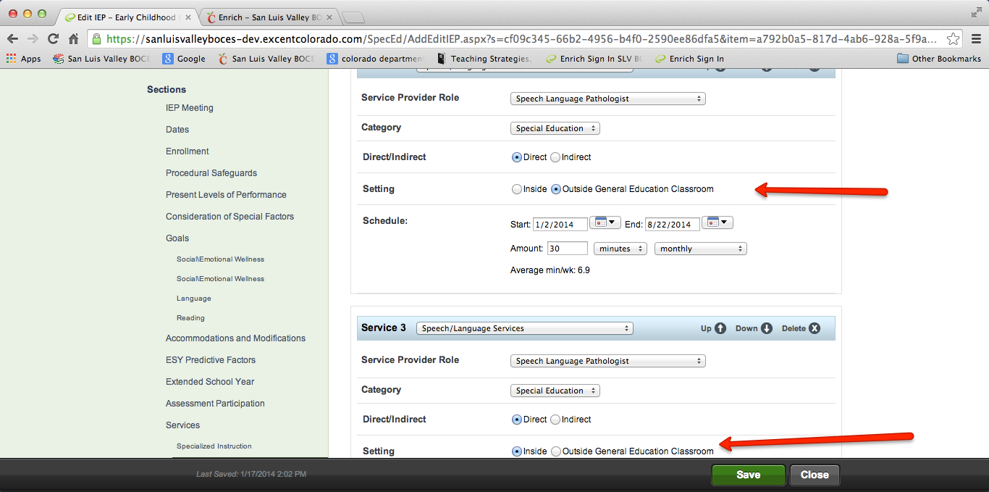

Then add the additional out of general education classroom for Kindergarten, with start date in the fall and end date the due date of the next IEP.

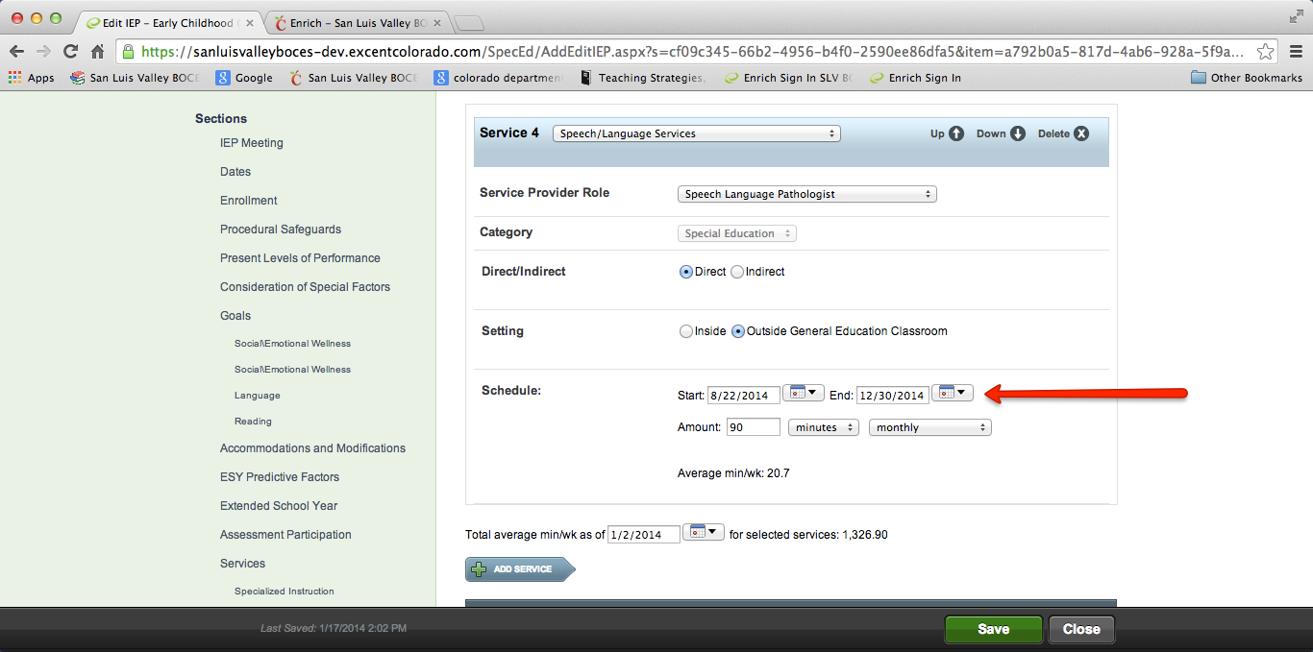

Describe your SLP services as 30 minutes a month in classroom, 30 minutes a month out of classroom while in preschool AND 90 minutes a month out of classroom beginning in Kindergarten in the Service Delivery Text Section of the IEP.

