ESY: Answer the first section “ESY Predictive Factors” for all students as Yes or No. If a student will be eligible by Predictive Factors, answer YES and more boxes will open up. (See below image for further explanation of Predictive Factors or Special Educational Procedural Manual).

Answer the Extended School Year question as Yes or No. There are 3 questions. Answer the last question if eligible or not as Yes or No.

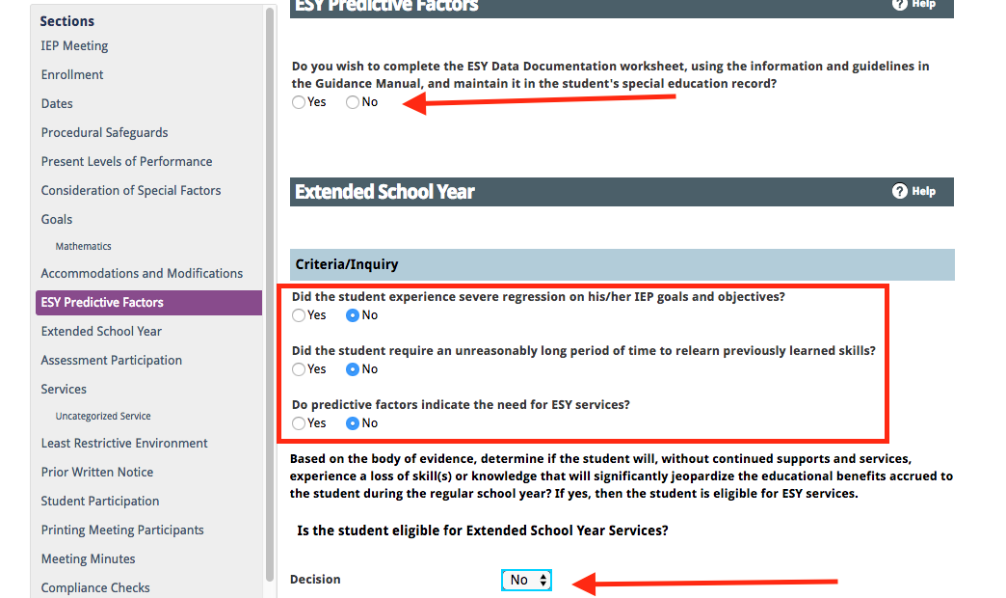

ESY Predictive Factors: This is a section that was added to the body of the IEP in the Enrich product. Prior to Enrich this was a separate document used to support the ESY decision. When considering predictive factors you’ll want to look at each factor to determine if it is relevant to the student in predicting regression and recoupment concerns. If a factor is considered and is not a concern, select no. If it is considered and is a concern select yes and if not a relevant consideration for this student select n/a. If you indicate yes or no to a factor you must type in the text box regarding the considerations.

Extended School Year: If a yes decision is made for Extended School Year services, you will need to complete a description of ESY services. This should be a description of the needs and goals to be supported during ESY. Specific service minutes offered to meet these goals and needs should not be listed. When yes is selected you will be prompted to indicate which goals relate to the ESY services for purposes of progress reporting. You will also be asked to indicate which services (not hours, but type of services) are determined to be appropriate for ESY. Be sure to relate services that are selected for ESY to specific data qualifying the child for these services and involve any service provider in this decision. If data does not support the services the IEP team may be asked to reconvene and review the decision.

If an annual goal/objective will be utilized for ESY, click “Yes” by the ESY prompt and the goal will be available for progress monitoring during ESY session. If an annual goal/objective will NOT be utilized for ESY, click “No”.

