Documenting Access to Record on Enrich

As our IEP files become more accessible on line, there is a need to document if you reviewed an IEP. This is the process for documenting that you reviewed an IEP and the purpose for the review. This is just like the Record Log that we sign when we view a paper IEP in the main file.

Go to the Profile Tab and then to go Audit Log.
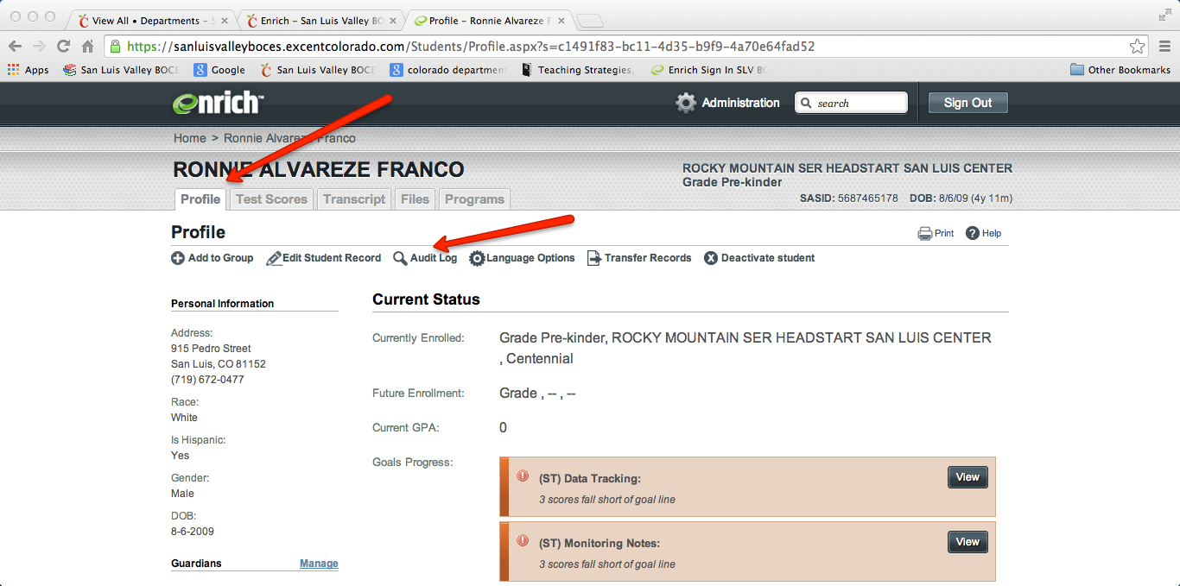

Click on + Add Access Log Entry

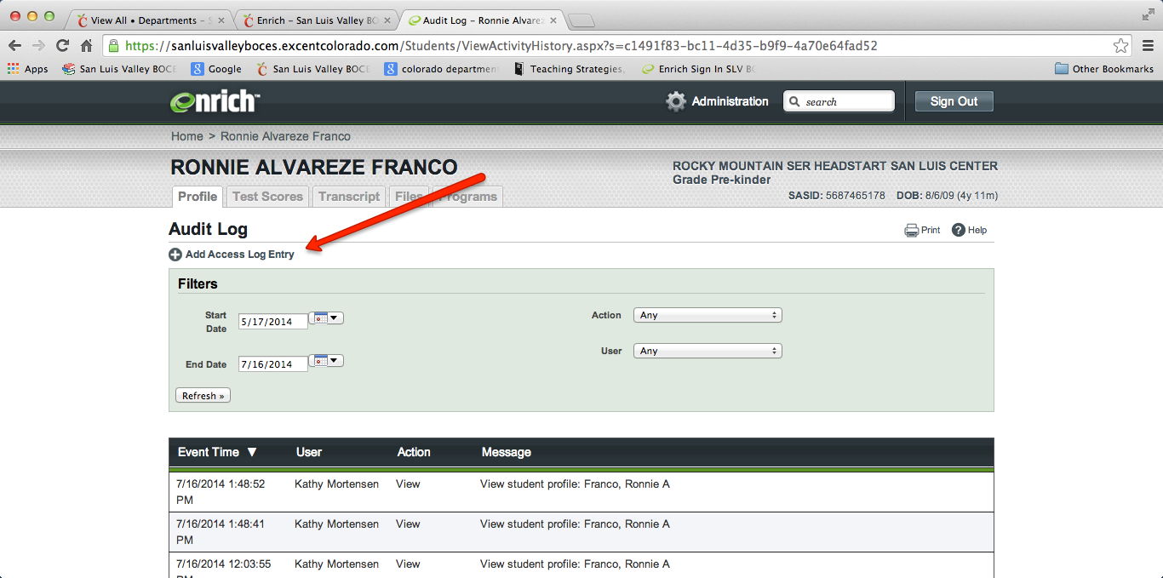

Complete the information as requested (Name, organization, Purpose). You are NOT able to edit this information, ensure it is accurate the First Time! (See image on next page)

