Deleting
Staff has the ability to delete many actions in Enrich up until the point of finalizing a document. Once a document is finalized it cannot be edited further.

For example, a special education teacher or provider can delete an IEP that was created in error BEFORE finalization. Simply open the draft IEP from the Programs tab. Once in the IEP document there is a “delete” option at the top of the screen. The same is true for many forms that are added under “Add Action.” Forms that cannot be deleted are those that are created as required documents through system set up. For example, after “Consent for Reevaluation” document is completed Enrich will require the team to complete an evaluation report and there is no option to delete this document once created in this manner.

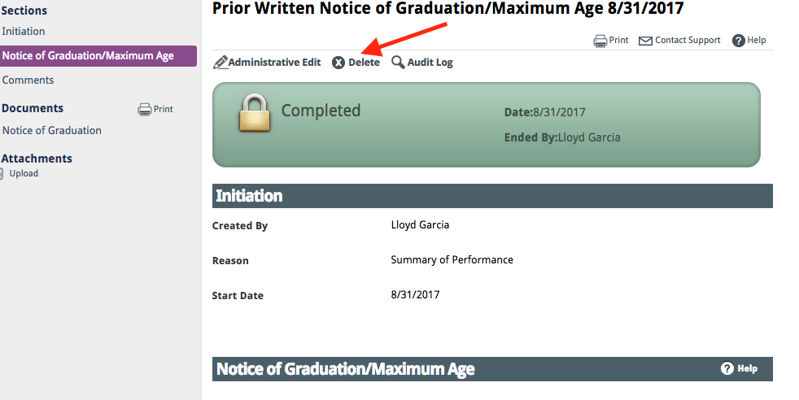

Items created within the draft IEP can be deleted before an IEP is administratively approved/finalized. In these cases enter the document that you are working on and look for an X next to the goal that you want deleted. By clicking on the X that goal or section will be removed. 