Creating an Initial Eligibility and IEP
When beginning the process for initial eligibility for a student, school psychologists and ECSE’s can begin the Enrich IEP process by providing all pertinent demographic information about the student to their records specialist, so they can enter the student in Enrich (Name, DOB, Parents name, ethnicity, address (if there are separate addresses for parents-please provide both), grade level, language spoken, potential IEP team members, etc.). Once entered, this student will have a “Profile” tab with no special education programs identified, similar to the image below. School psychologists and ECSE’s are responsible for uploading the referral into Enrich so all providers have access to referral information.

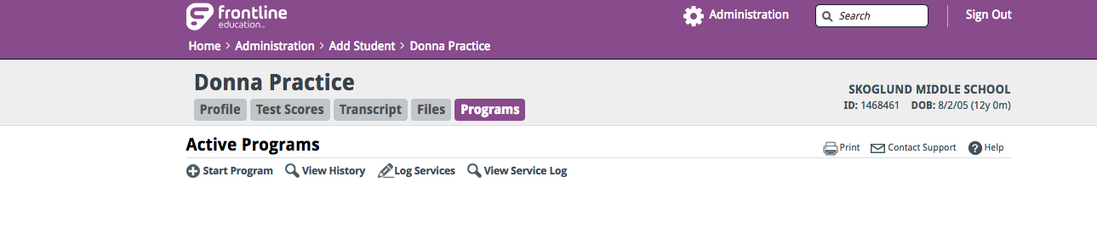
To initiate the initial eligibility process click on “+ Start Program” and select “Special Education” in the drop menu. Another drop down menu will appear; select “Consider Eligibility for Special Education” and then click “Next.”

At this time a document will be created which is titled “Consider Eligibility for Special Education.” Complete all fields of this document, save and finalize. It is not necessary to enter comments unless relevant. Note that the start date and outcome date should be the date you initiated the process, essentially the date of referral. There will not be an Enrich referral form, so this document indicates when the referral was initiated. Please upload the initial referral form you use into Enrich.

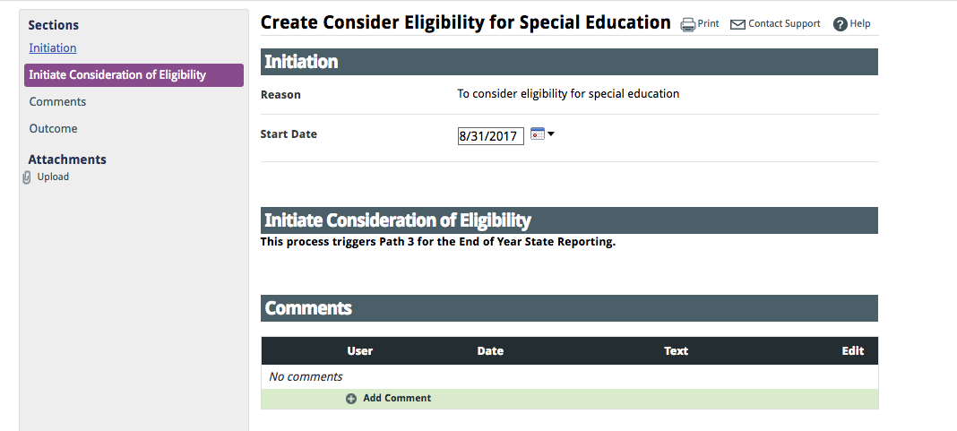

Select the following Outcome: “Complete; start with Consent for Evaluation”
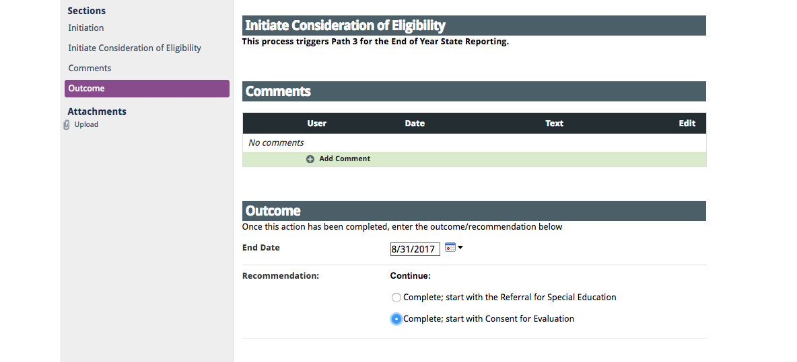

Next, a document called “Consent for Initial Evaluation” AND “Consent for Initial Provision of Services “ will be generated.

Click “Create” to begin working on this part of the Initial Eligibility process. See image below
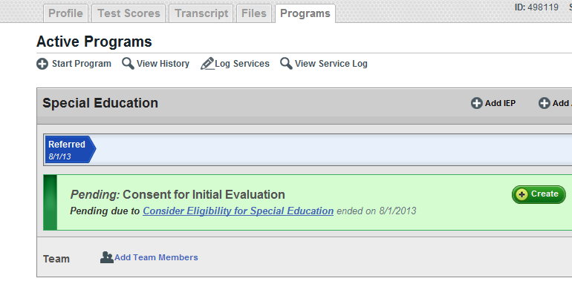
The school psych or ECSE will complete all sections of the “Consent for Initial Evaluation” document (up through the consent to evaluate). The start date should be the date the form was created. The other fields indicate what dates and information should be entered. The decision regarding areas to be evaluated should be determined through evaluation planning. All elements of the prior written notice section must be completed without the use of “not applicable.” Remember to differentiate in the motor section if OT, PT or both will be evaluating.

Print the document and have parents or guardians sign.
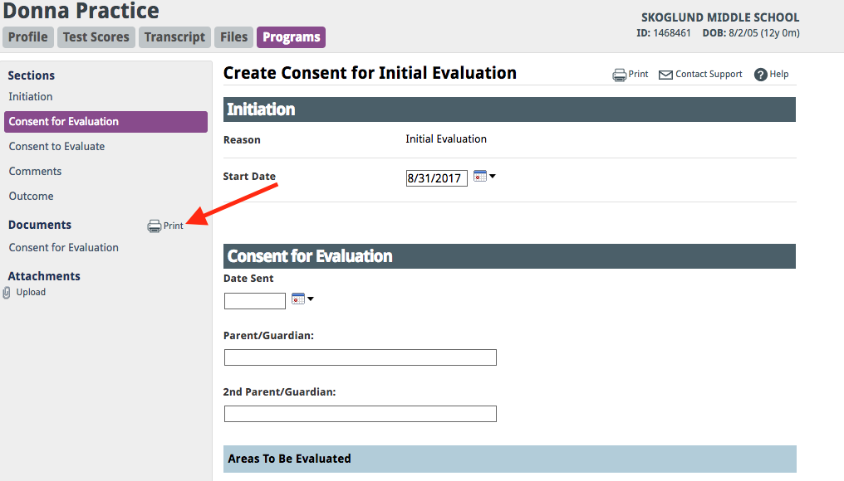

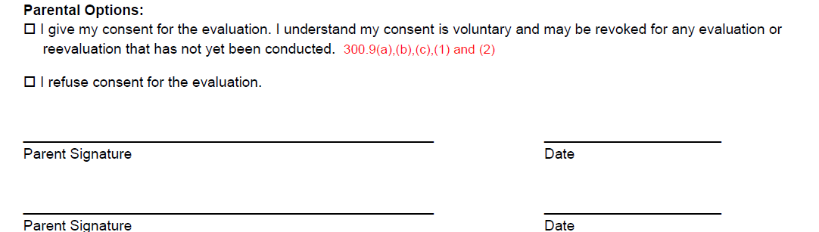

After the outcome of parent consent is determined, complete the consent to evaluate and outcome sections. Save and finalize the document. The date that response was received will initiate the 60 day timeline for the Initial Evaluation process to follow. Upload the signed Consent to Evaluate Form Immediately so that related service staff can verify permission has been obtained. Case Manager and/or School Psychologist/ECSE also need to notify all applicable related service staff that they can now evaluate.

If the parent refuses consent: In this instance select that consent was refused. A Prior Written Notice document will need to be completed by the School Psychologist or ECSE. Find Prior Written Notice of Special Education Action in +Add Action. Complete the PWN documentation process to end the consent process.
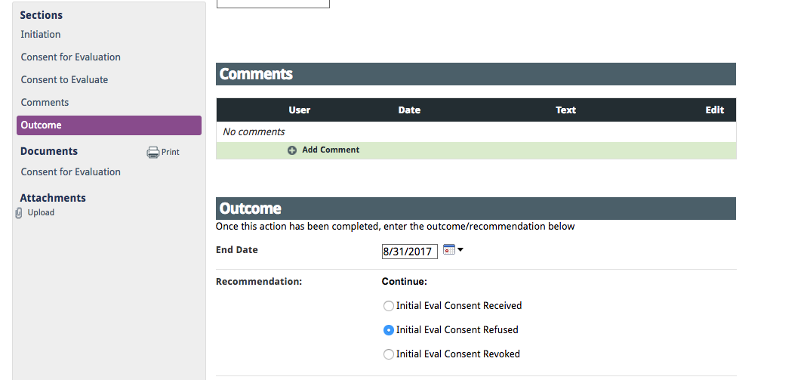

If the parent gives consent: An “Eligibility Determination”, “Evaluation” and “Initial Consent” document will be automatically generated. Complete the assessments as determined by the “Consent for Evaluation” and begin entering that information into the “Evaluation” document. All evaluations are written in Enrich into the same evaluation format/form. There are NOT separate evaluation forms for each “discipline”. The start date of the “Evaluation” document can be the date you begin working on the document. It is best practice to include hearing and vision screening information in this report, which can be found by contacting your school nurse practitioner.
The school psychologist or ECSE will select yes to the sections of the evaluation report that were determined to be areas of concern and relate to the “Consent for Evaluation”. All other areas are marked no.
The school psychologist or ECSE, when completing this “Evaluation” document will need to enter the date the evaluation report is completed. This date should be within 60 days of the Consent for Evaluation.

Prior to indicating the outcome, print the draft evaluation document and review it at the formal meeting with the IEP team. Make appropriate changes and then select an outcome at the end of the formal meeting. All providers need to put their information into this ONE evaluation document. Once all evaluation information is complete, School Psychologists, ECSE will finalize the evaluation document. Case manager or school psychologist/ECSE can send parents a completed copy.

REMINDER: ONCE THE EVALUATION IS COMPLETE, INSERT THE DATE of the IEP meeting. This date will generate the next triennial date.

A. Eligibility and IEP meeting are separate:

To create a notice of meeting that is separate from an IEP meeting, go to the student’s dashboard, select “Create” and work through the various prompts. The start date is the date you started working on the document. You will need to select “Create a New Meeting” to indicate when the meeting will occur with the team to review eligibility. After you create this meeting send the meeting notice to the parent by printing it from the documents section on the left side of the screen.

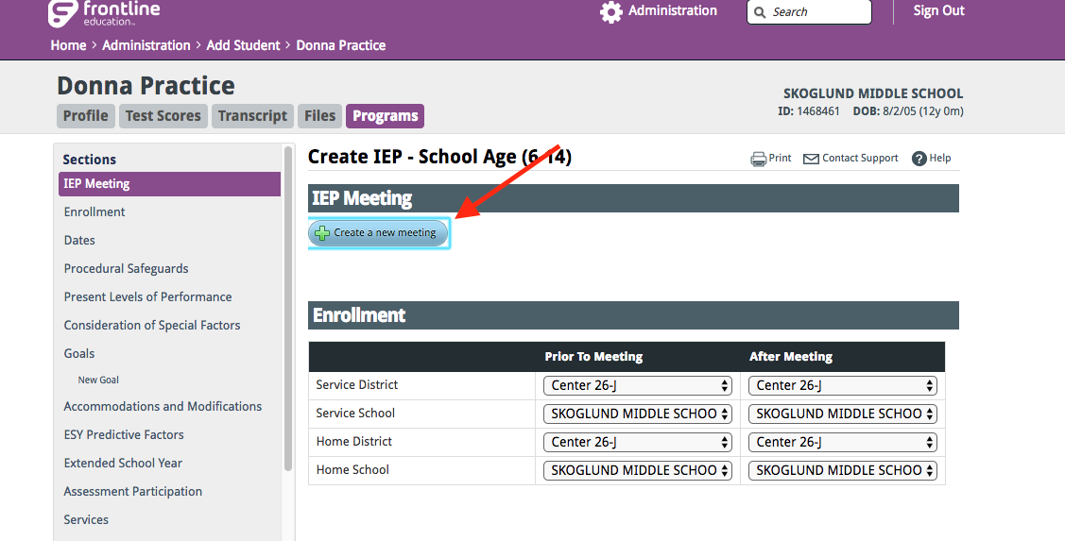

Complete the Eligibility Meeting and Student Participation sections and create a draft of the Eligibility Determination section. At the meeting you’ll finalize the Eligibility Determination sections and get participant signatures on this document. School Psychologists, SLP’s and ECSE’s need to complete the appropriate “Eligibility” document. You can print copies of any potential category as drafts that can be signed at the meeting once the determination has been made. Complete and finalize the Outcome section in Enrich. Upload the signed eligibility form into Enrich.

Note: Once the Evaluation and Eligibility documents are administratively approved they will no longer show up on the student’s dashboard. They can be found by clicking on “View History” under a student’s “Programs” tab.
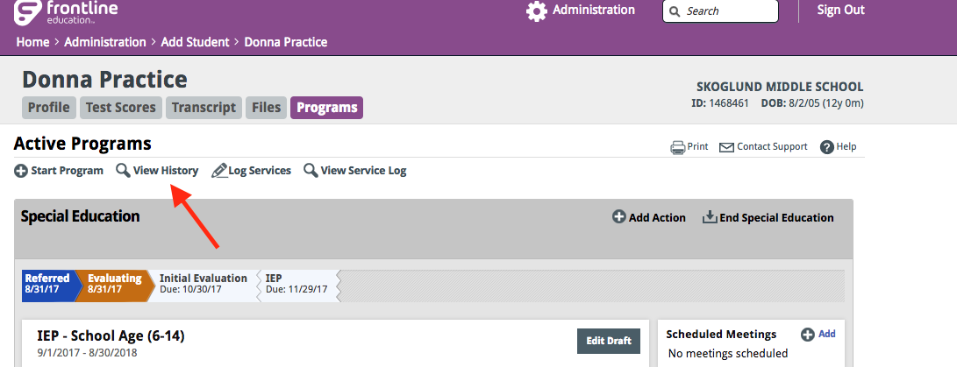
B. IEP Meeting and Eligibility in one meeting:

Create and draft an IEP. If the IEP is not automatically generated, you can create a draft IEP. To create an IEP, select “+ Add IEP” on the student’s dashboard. Create the appropriate IEP and all relevant sections for the draft. More information on the IEP process can be found in the Annual IEP section of this manual. Click on “create notice of meeting” embedded within the IEP and complete the notice of meeting, indicating eligibility and IEP development are the purpose of the meeting.

REMEMBER TO NOTIFY YOUR RECORDS CLERK WHEN AN IEP IS FINALIZED!!!!

