Creating an Annual IEP

In many cases you will be creating an annual IEP for your students. Find the Programs tab for the relevant student and select “+ Add IEP” on the right side of the screen. This will allow you to select from a menu to generate the appropriate IEP. Enrich is set up to initially select the appropriate type of IEP related to a student’s age, although you will be given the choice of the variously aged IEPs in a drop down menu in case there is a need to override Enrich’s selection. (This includes selecting a transition IEP for students in 8th grade.). Once the IEP type is selected a draft will be created for you to work from.
You can tell that a student’s IEP is about to be due by looking at the student’s profile as a yellow triangle shows next to the item IEP Review as the due date draws near. You can create an IEP at any time before the due date. (PS we are told that eventually the Chevron/Due Dates will no longer be available.)
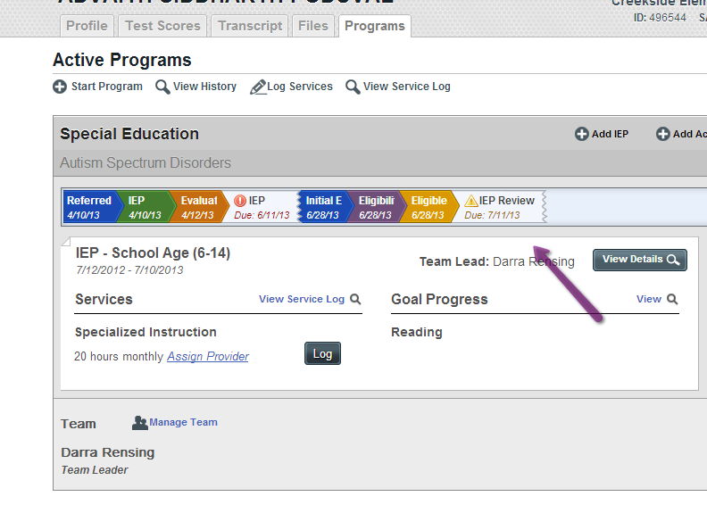

You are also able to view when IEPs are due on the teacher dashboard when you sign in. You can see in the sample teacher dashboard below that there are three Plans (IEPs) due after September 28th. It is up to each teacher to complete all IEPs and evaluations prior to the required due dates. Enrich is only as accurate as the data that is in the system, so be sure to check the due dates on the current IEP documents as well as in Enrich to be sure that the due dates are accurate.
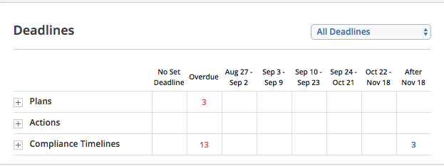

After creating an IEP you’ll want to first “Create a New Meeting.” Click on this button while working inside the IEP draft document and complete the fields.

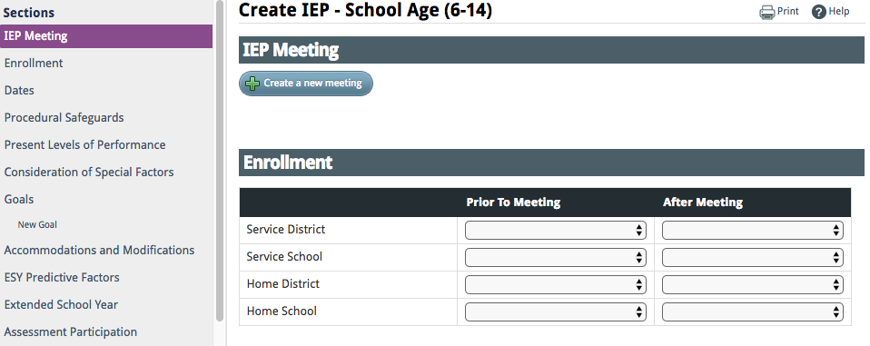

Fill in the roles of each member who will be in attendance. Be certain to include a Special Education Director or Designee as a required role in the meeting. If a member is required but will be absent, enter his or her role and then select Absent. This will generate a meeting excusal document to be completed. (Related Service staff and General Education teachers are required). You do not need to mark Absent for Principals and other non required attendees....as this generates a non needed excusal. Parents can be marked as absent. You will answer 2 questions about parental attendance at the end of the IEP completion in Enrich.
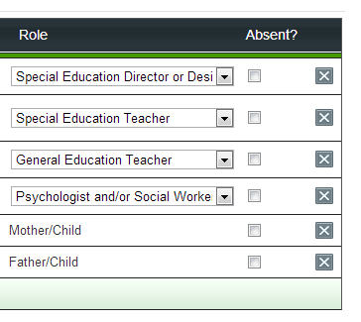

When the Notice of Meeting is complete, scroll to the bottom of the IEP document and print this notice. Send a copy to the parent and IEP team to confirm the meeting date.

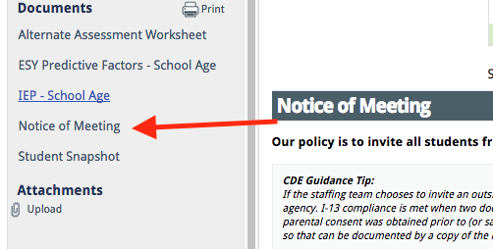

Begin to draft the IEP document. You can save and close the document at any time in the process and return to the draft document by finding the document on the student’s dashboard and clicking “Edit Draft.”
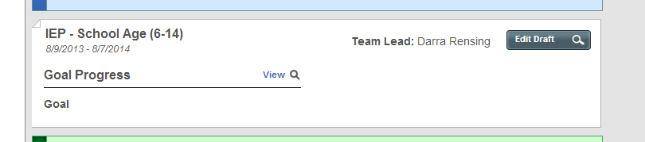
It is best practice to validate as you complete and review the IEP. Validate can remind you about missing components.
As you work through the draft IEP, follow the prompts and guidance for each section. Guidance is embedded in the IEP and evaluation documents. Guidance can be found within each section or by clicking “? Help.” See the image below for an example.

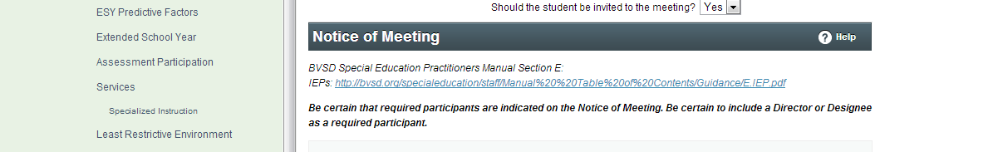

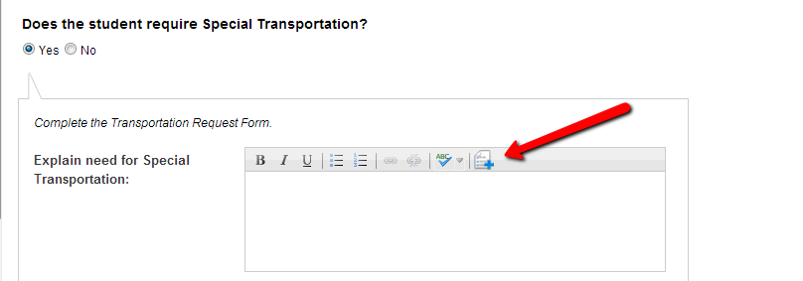

Special Factors: In the Enrich IEP forms are embedded into the special factors section. If you select yes to various areas such as Behavior Intervention Plan and Transportation, the relevant form will be generated and must be completed as part of the IEP process. Behavior Plans and Transportation documents can also be created under “+Add Action” outside of the IEP meeting at any time throughout the year. IEP Behavior Plans require an FBA (IDEA requirement). FBA requires evaluation consent. If embedded in Initial or Triennial follow that evaluation consent process. If FBA need is outside of Initial or Triennial, follow the special evaluation process.

Ensure you invite the appropriate personnel to every IEP meeting to assist in completing the following:

STUDENTS WITH HEARING IMPAIRMENT REQUIRE A COMMUNICATION PLAN/ This is completed by the Teacher of the Deaf and Hearing Impaired (DHH).

STUDENTS WHO ARE DEAF/BLIND REQUIRE LEARNING MEDIA & COMMUNICATION PLAN./This is completed by Teacher of VI (Visual Impaired)and Teacher of DHH.

STUDENTS WITH VISUAL IMPAIRMENT REQUIRE A LEARNING MEDIA PLAN/This is completed by the Teacher of the Visually Impaired.

STUDENTS WITH HEALTH CARE NEEDS REQUIRE A HEALTH CARE PLAN/This is completed by the school nurse.

STUDENTS IDENTIFIED AS LEARNING ENGLISH AS A SECOND LANGUAGE/This is completed by case manager with input from applicable related services. (See Special Ed. Procedural Manual for Guidelines).

STUDENTS IDENTIFIED AS NEEDING ASSISTIVE TECHNOLOGY/This is completed by case manager with input from applicable related services.

Goals: When completing goals and objectives complete all sections and boxes to ensure measurability. When selecting the related standard, the expectation is to relate the goal to that student’s grade level when at all possible. Colorado no longer has Access Skills as an option for reporting standards. Instead we are using Extended Evidence Outcomes for modified standards and Extended Readiness Competencies for Access Skills. The Comprehensive Health standards also have some standards that were previously listed under Access Skills. These can be found within the “Add Standards” link after selecting grade levels and standards. Only select the option “detailed progress monitoring” if you want to monitor a particular goal within Enrich. Goals and objectives need a probe selected for progress monitoring. Each goal/objective must use a different probe. If you need probe titles added, contact your Records Specialist. If an annual goal/objective will be utilized for ESY, click “Yes” by the ESY prompt and the goal will be available for progress monitoring during ESY session. If an annual goal/objective will NOT be utilized for ESY, click “No”.

Outline of Goals on Enrich:
- Progress report – This is narrative, there is a pull down for frequency.
- Area of need can be a general category, behavior, reading, math, social skills, etc. This is a pull down window.
- Start Date – This is the date the goal will be implemented. The projected achievement date one year following the start date. This may self populate.
- Measurable goal-a statement of what the student can reasonably learn that we teach them in one year. It needs to be measurable and that measure needs to be the same as the baseline measure.
- Objectives. Objects for ID (Intellectual Disability) are mandatory. Objectives can be written for other students but are not required for all students. To break down an annual goal into steps for the year you can utilize objectives. Objectives can be changed without an IEP meeting, where as annual goals require an IEP meeting or parental agreement to amend/IEP amendment to make changes.
- Unit of Measurement is really the “target” improvement we have already stated in the goal, i.e.: 80%; 4/5 times; 3 demonstrations. This target is related to the baseline in the same measure.
- Evaluation Method-this is explained by just checking the boxes.
- Standards-You can link goals/objectives to standards. For students with higher needs you can drill down to the lowest standard or EEO for most subjects.
- Progress Monitoring-You only have pull down choices for probe types. Choose your frequency.

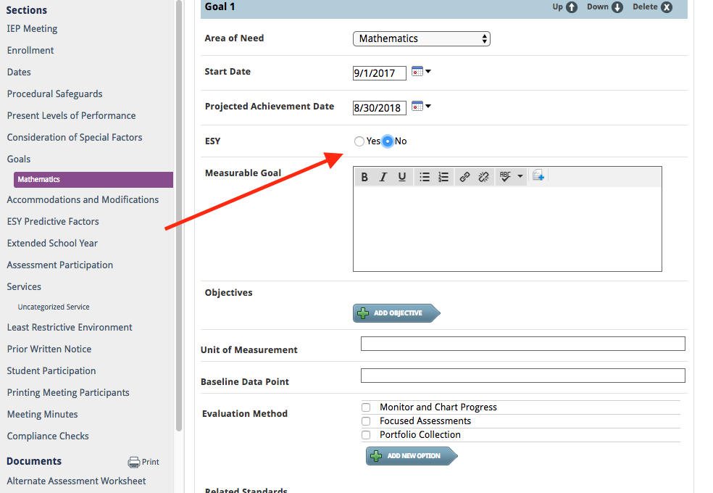

ESY: Answer the first section “ESY Predictive Factors” for all students as Yes or No. If a student will be eligible by Predictive Factors, answer YES and more boxes will open up. (See below image for further explanation of Predictive Factors or Special Educational Procedural Manual).

Answer the Extended School Year question as Yes or No. There are 3 questions. Answer the last question if eligible or not as Yes or No.

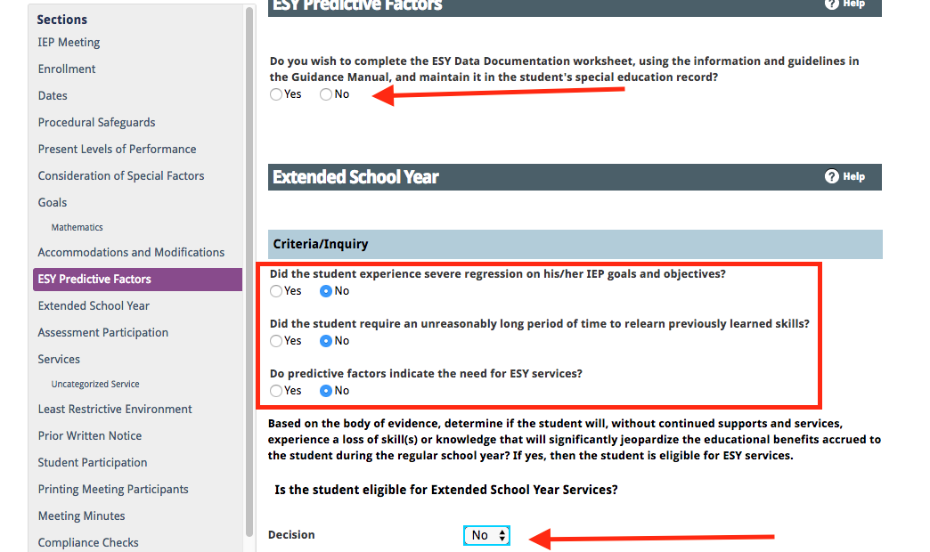

ESY Predictive Factors: This is a section that was added to the body of the IEP in the Enrich product. Prior to Enrich this was a separate document used to support the ESY decision. When considering predictive factors you’ll want to look at each factor to determine if it is relevant to the student in predicting regression and recoupment concerns. If a factor is considered and is not a concern, select no. If it is considered and is a concern select yes and if not a relevant consideration for this student select n/a. If you indicate yes or no to a factor you must type in the text box regarding the considerations.

Extended School Year: If a yes decision is made for Extended School Year services, you will need to complete a description of ESY services. This should be a description of the needs and goals to be supported during ESY. Specific service minutes offered to meet these goals and needs should not be listed. When yes is selected you will be prompted to indicate which goals relate to the ESY services for purposes of progress reporting. You will also be asked to indicate which services (not hours, but type of services) are determined to be appropriate for ESY. Be sure to relate services that are selected for ESY to specific data qualifying the child for these services and involve any service provider in this decision. If data does not support the services the IEP team may be asked to reconvene and review the decision.

Services: In the Enrich IEP product you must enter the location of services as either inside or outside of the general education classroom and as direct or indirect. This means that you might have multiple services listed for a student to address the various options. You may have a service time that is direct in the general education class as well as a separate service outside of the general education class and a third service noted for indirect service (consult.) A service delivery statement is written to describe these services and the use of an integrated service delivery statement can be used. These services will be calculated by Enrich along with the length of your school’s school day to recommend a percentage of time in the general education classroom when you get to the LRE section of the IEP. Remember if you are a 4 day a week school, you need to use weekly to document your time vs. daily otherwise the LRE is calculated on a 5 day week!!!!
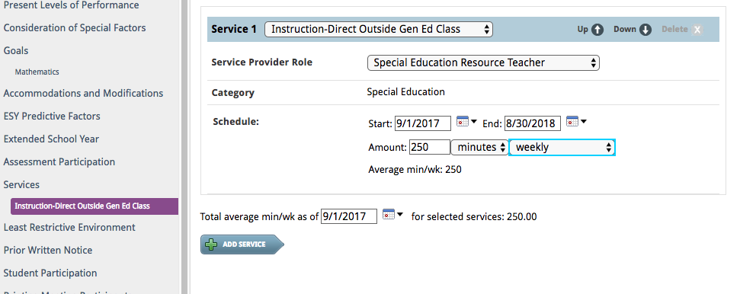
Printing Meeting Participants: When printing an IEP draft for the IEP meeting, please select the check box stating “Complete this section to print the participant names on the IEP document and document if the parent did not attend but still participated..” This will print the members indicated on the Notice of Meeting into the draft IEP.

Student Snapshot: A student snapshot is a new document in Enrich. This is an IEP at a glance which can be used to support IEP implementation. It is still expected that all staff working with the student on an IEP have access to the full IEP document.

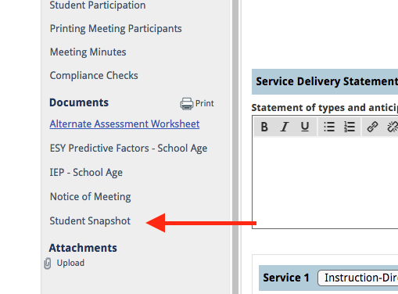

Remember to notify your Records Clerk when an annual is validated, finalized and completed. Once the IEP is administratively approved, it cannot be changed unless you complete an amendment or have a Special Request IEP meeting.

