Creating a Triennial Eligibility and IEP
School Psychologist or ECSE will begin the process for a triennial eligibility/re-evaluation for a student. Begin by searching for the student in Enrich. When found, select the student’s “Program” tab. Click on the “+Add Action” link. This will create a drop down menu. In the menu select “Consent for Reevaluation” and then click next.

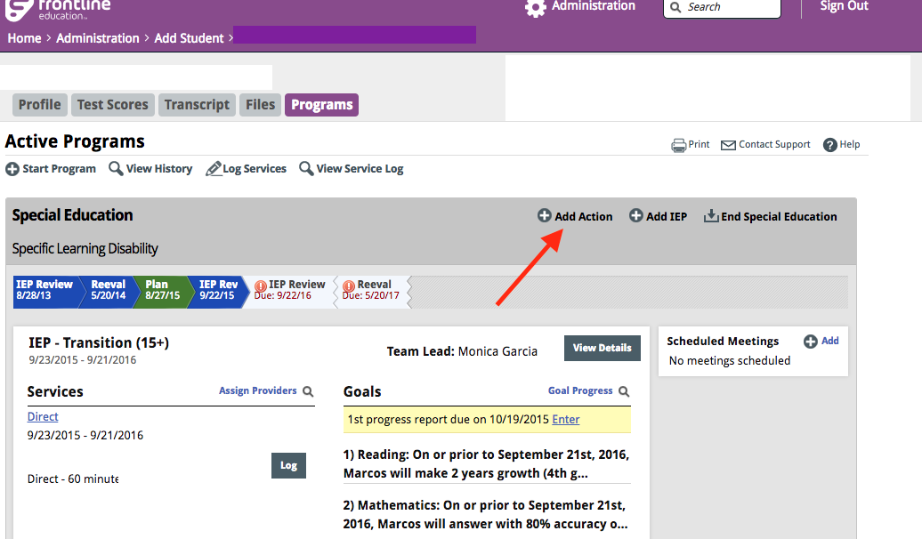

At this time a document will be created which is titled “Consent for Reevaluation.” Complete all sections of the “Consent for Reevaluation” up through the consent to evaluate section. The start date should be the date the form was created. The other fields indicate what dates and information should be entered. The decision regarding areas to be evaluated should be determined through an evaluation planning meeting. All elements of the prior written notice section must be completed without the use of “not applicable.” Reminder: Differentiate OT/PT or Fine Motor/Gross Motor in the Motor section.

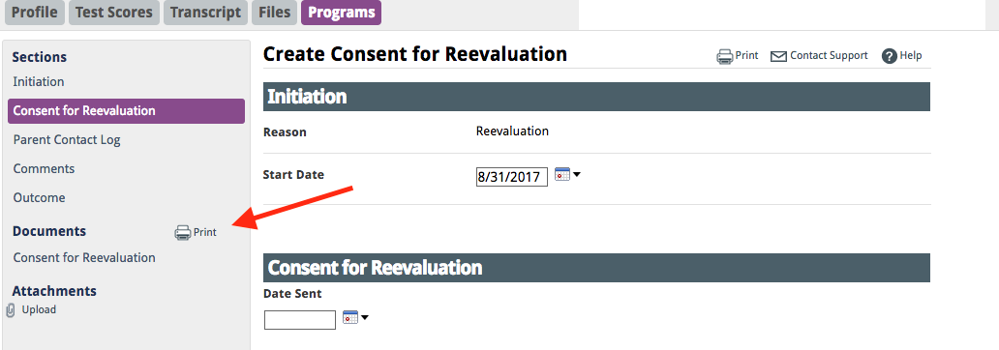

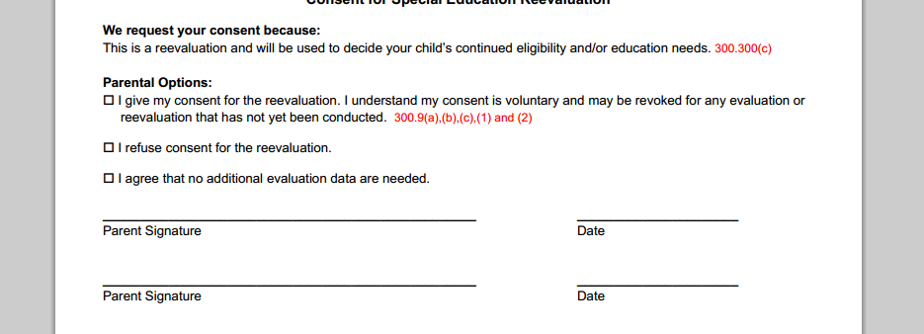

After the outcome of parent consent is determined, School Psychologists or ECSE will complete the consent to evaluate and outcome sections. Save and finalize the document. Upload the signed consent to evaluate into Enrich.

At this point, an “Eligibility Determination” and “Evaluation” document will be generated and can be found on the student dashboard. Complete the assessments as determined by the “Consent for Reevaluation” and begin entering that information into the “Evaluation” document. The start date of the “Evaluation” document can be the date you begin working on the document. It is best practice to include hearing and vision screening information in this report, which can be found by contacting your school nurse practitioner. The date evaluation is complete should be the date of the IEP meeting. This is the date that generates the due date for the next eligibility meeting (Triennial). Remember to select yes to the sections of the evaluation report that are determined to be areas of concern and relate to the “Consent for Reevaluation”. All other areas are marked no.

Prior to indicating the outcome, print the draft document and review it at the formal meeting with the IEP team. Make relevant changes and then select an outcome at the end of the formal meeting. Ensure that all evaluators have put their information in the ONE evaluation form. Validating during IEP completion supports you in ensuring you have completed all sections of the IEP. Once complete, finalize the document and send parents a completed copy.

You’ll also need to complete the “Eligibility” document. On the student’s dashboard select “Create” on this document and work through the various prompts. Start date is the date you started working on the document. You will need to “Create a New Meeting” to indicate when the meeting will occur with the team to review eligibility and develop the IEP if student is eligible. After you create this meeting send the meeting notice to the parent by printing it from the documents section on the left side of the screen.

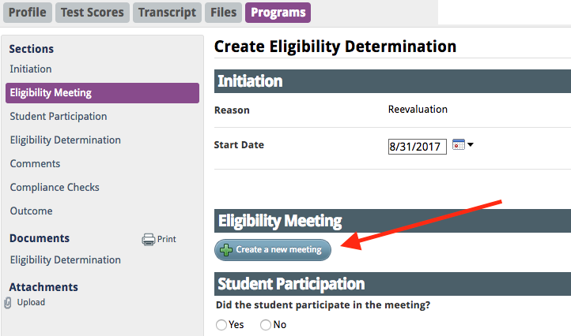

Complete the Eligibility Meeting and Student Participation sections and create a draft of the Eligibility Determination section. At the meeting you’ll finalize the Eligibility Determination sections and get participant signatures on this document. The Outcome section can then be completed and the document can be finalized in Enrich.

Note: Once the “Evaluation” and “Eligibility” documents are administratively approved they will no longer show up on the student’s dashboard. They can be found by clicking on “View History” on the student’s Profile tab. Remember to upload the signatures pages for eligibility into Enrich.

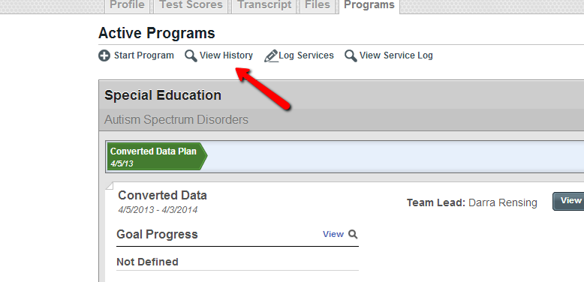

You’ll note that an IEP is not automatically generated in this process. This gives you the ability to meet to determine eligibility separate from an IEP meeting. You may hold the eligibility and IEP meetings together, as is typical practice in the San Luis Valley. Either way you’ll need to create and draft an IEP in addition to the other forms noted. To do this, select “+ Add IEP” on the student’s dashboard. Create the appropriate IEP and all relevant sections for the draft. More information on the IEP process can be found in the Annual IEP section of this manual. Notify your Records Specialist once the Triennial IEP is completed and finalized in Enrich

Note: If a student does not qualify you will finalize all documents and upload the signature page to Enrich. Records Specialist will administratively approve the process and ensure the child is exited from special education. No change of status form is necessary in this case. Until this is processed it will look like the student has a triennial due in three years under his or her student Programs tab. Once processed and exited by Records Specialist the student’s Programs tab will show that they are no longer identified under special education. A student who is exited will have a Programs tab that looks like the image below. The school psychologist or ECSE will then generate a Prior Written Notice (found in Add Action/Prior Written Notice of Special Education Action). Please finalize the PWN and send the PWN to the family if the student is found not eligible for services. REMEMBER TO NOTIFY YOUR RECORDS CLERK WHEN AN IEP and PWN ARE FINALIZED!!!
