Creating In and Out of State Transfers
When beginning the process for an in or out of state transfer IEP for a student, begin by providing all demographic information needed to Records Specialist (Name, DOB, Parents name, ethnicity, address (if there are separate addresses for parents-please provide both, grade level, language spoken, potential IEP team members, etc.).
Once the student is in Enrich, you begin the transfer process by completing a Transfer IEP. Go to “Start Program”.
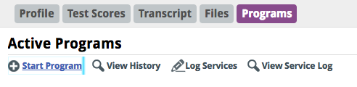
A drop down menu will appear. Select “Special Education.” Another drop down menu will appear; select either “Transfer From Within State” or “Transfer From Another State” and then click next.
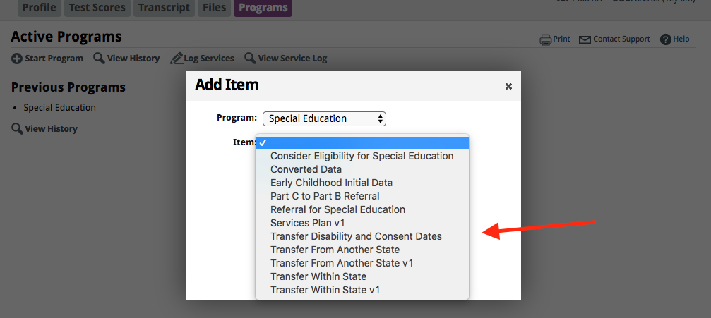
Once the incoming IEP is reviewed and you’ve created either an in- or out-of-state transfer document, you will need to enter information in all fields. Please see the SLV BOCES Transfer Guidance on how to make the decisions to accept or deny an IEP based on what is permissible by our state. These decisions are made as an IEP team with the family.
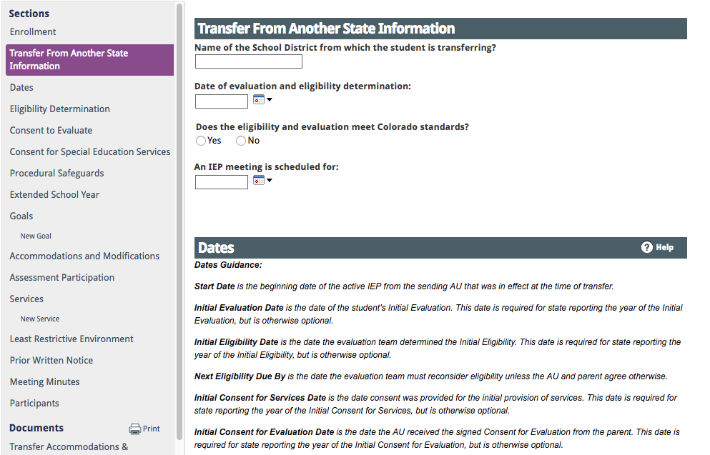
When working in a transfer IEP document the Start Date should be the date of the most recent IEP you are receiving. If the IEP is not accepted, the Planned End Date is 30-60 days (30 for In-State, 60 for Out-Of-State) after the meeting when a new eligibility must be determined and/or a new IEP needs to be developed. If the transfer IEP is accepted, the Planned End Date it is the date that the IEP will expire.

If you are accepting an incoming eligibility and IEP, you will enter the end date, date of next review, latest evaluation date and next evaluation to match the IEP you are accepting. The next IEP and eligibility will be due based on those dates.

Complete all elements of the transfer IEP document in the same way as you complete the Annual IEP, using the incoming IEP to inform each segment.

NOTIFY RECORDS CLERK WHEN TRANSFER FORMS ARE FINALIZED!!!!!

