Fill in the roles of each member who will be in attendance. Be certain to include a Special Education Director or Designee as a required role in the meeting. If a member is required but will be absent, enter his or her role and then select Absent. This will generate a meeting excusal document to be completed. (Special Education, Related Service staff and General Education teachers are required). You do not need to mark Absent for Principals and other non required attendees....as this generates a non needed excusal. If a parent is absent, mark the absent box and an excusal will NOT be generated. There are 2 questions to answer at the bottom of IEP completion in Enrich to address parent absences and participation at IEP meeting by other means. See second image below.
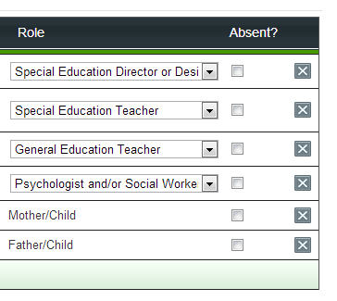
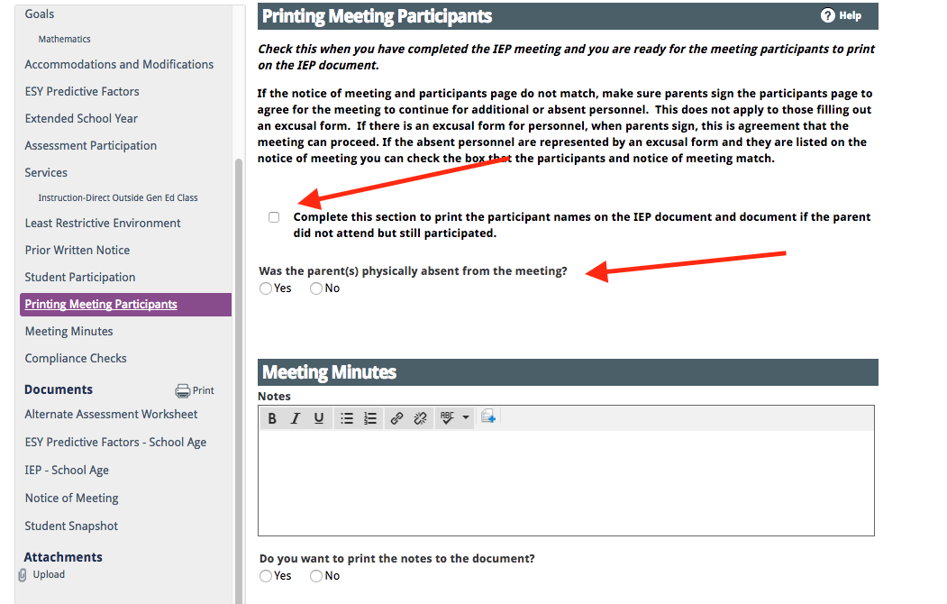

The related service provider that will not be in attendance should have the excusal section completed for parent signature before the IEP meeting is held.

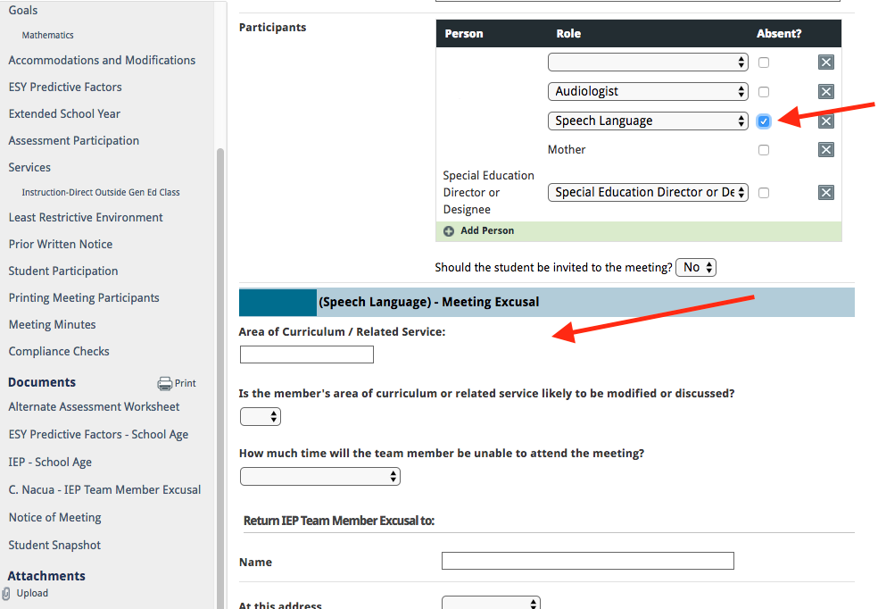

To Print the completed Meeting Excusal for signature, go to the “Print” section in the green section (left hand side) of Enrich. You can print by clicking on “Excusal for....” or choosing the Print Button and selecting the section you want to print. Remember to upload the Excusal Signature after the IEP meeting.
