Benefits of Program

- Coaching Supports
- Mentor Support
- Resource Bank
- Small Seminar Size
- Mixture of Online and Face to Face Learning
- Low Cost

Who should do an Alternative Licensure Program?

Alternative educator candidates range in age from 22 to 82 and come from all walks of life. What they have in common: the drive to make a difference in the lives of kids by becoming educators. If you know of someone who
Recently graduated but have never enrolled in or did not complete a teacher preparation program;
- Is an early career changers, who has graduated from college, worked for a few years, and realizes that they want to become educators;
- Is a mid-career changer, and looking for a pathway to make a difference in the lives of kids by becoming an educator;
- Is a community member who has college degrees and life experiences, and wants to affect the lives of the children in their community;
- Is a paraprofessional who has completed their Bachelor’s degrees and is seeking a pathway to licensure or;
- A retired military members who would like to “serve again” by becoming an educator.

For further information contact Nita McAuliffe at nmcauliffe@slvboces.org or 719-587-5417.

San Luis Valley BOCES
Member Districts

District Superintendent
Alamosa Robert Alejo
Centennial Toby Melster
Center Carrie Zimmerman
Creede Collin Vinchattle
Del Norte Chris Burr
Moffat Christina Larson
Monte Vista Scott Weideman
Mountain Valley Travis Garoutte
North Conejos Curt Wilson
Sanford Kevin Edgar
Sangre De Cristo Brady Stagner
Sargent Brian Crowther
Sierra Grande Darren Edgar
South Conejos Dr. Emma Martinez

San Luis Valley BOCES Alternative Licensure Program
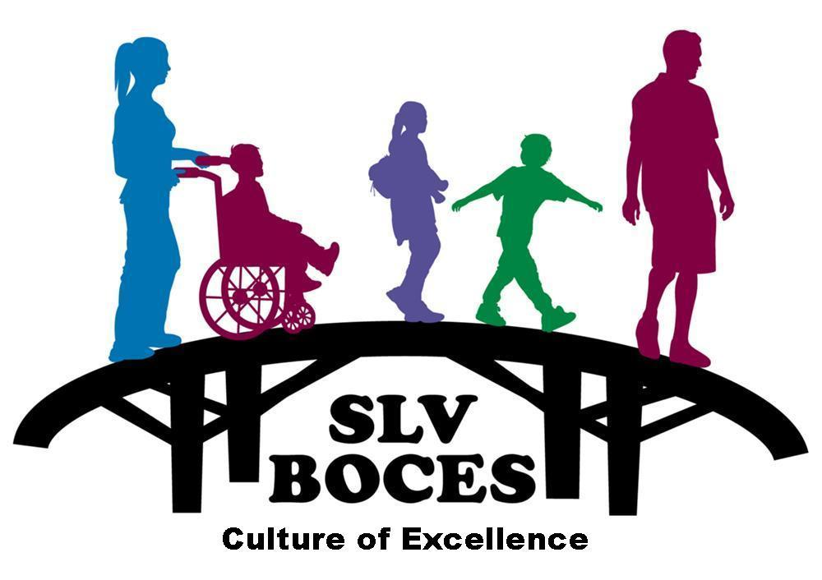

A Regional Education Agency

2261 Enterprise Dr.  Alamosa, CO 81101  (719) 589-5851
www.slvboces.org

Our Services
The San Luis Valley Alternative Licensure Program was created for aspiring educators who already have specific content expertise but need training to learn how to deliver instruction.

San Luis Valley BOCES Alternative Licensure Program

The purpose of the Alternative Training Program is to provide member districts the opportunity to acquire well-qualified individuals to teach and further enrich the school district. The program would also accomplish the ability to develop teaching staff in difficult to recruit teaching areas.

San Luis Valley BOCES Alternative Licensure Program is a 1-year certificate (the duration of program) that allows you to teach while you complete a certification program. This license can only be issued once you are hired to teach in a Colorado school.
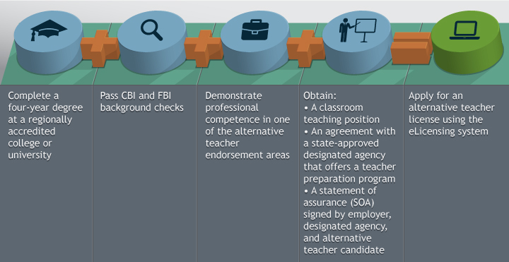

First Things First …
- Candidate must already have a bachelor’s degree or higher to be able to qualify for an alternative teacher license.

- Submit a set of fingerprints to the Colorado Bureau of Investigation for licensure purposes by following the guidelines set forth on the CDE Web site. http://www.cde.state.co.us/cdeprof/altteacheroverview

- CDE cannot issue any type of credential without first receiving from CBI and FBI a cleared background check or until one of CDE’s investigators has cleared your background.

- Create an account in CDE’s eLicensing system. This will allow CDE to ensure your background checks “catch up” with you, and is the account through which you will submit all applications for educator licensure.
Next …
- Complete and submit an application for an alternative teacher license. This is the “teacher” application in the eLicensing system. (The answers you provide will result in your submitting an appropriate application.)

- If you have not yet obtained a teacher position at the time of application, you will receive an “alternative licensure pending employment/program” status. This information will be reflected in three places: the applicant’s personal eLicensing account, the district eLicensing verification access account and the public educator credential search.
Finally …
- You must have your alternative teacher license in hand in order to be in the classroom. (Be sure to provide your school/district and program a copy of your alternative teacher license.)

- An alternative teacher license is valid only as long as you are actively participating in an alternative teacher preparation program. Should you withdraw or be dismissed from the program, the program will submit a Change of Status form to CDE and your alternative license will be expired.

