Adding Actions
Various documents related to the IEP can be created and added to a student’s program by adding an action. To do this, begin by searching for the student in Enrich. When found, select the student’s “Program” tab. Click on the “+Add Action” link. This will create a drop down menu. In the menu select from the various documents available.

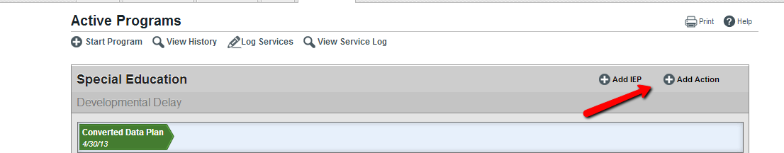

Documents under “Add IEP” include:
Behavior Intervention Plan
Consent for Initial Provision of Special Education and Related Services
Consent for Medicaid Reimbursement
Consent for Reevaluation
Consent to Invite Agencies Related to Transition
Evaluation
IEP Amendment Waiver
Manifestation Determination
Notification of Medicaid Benefits
Part C to B Referral
Prior Written Notice of Graduation
Prior Written Notice of Special Education Action
Request to Release or Secure Confidential Information
SLD Initial Evaluation Extension
Summary of Performance
Special Evaluation

After creating a form, be sure to complete all fields and finalize a document so that it can move from a draft to a finalized format. Note: Once these documents are finalized they will no longer show up on the student’s dashboard. They can be found by clicking on “View History.”

